
Beta 2 Guided Tour
Building your first XML Web service, Web Form, and Windows® Form Applications
Building the next generation Internet just got easier.
June 2001
© 2001 Microsoft Corporation. All rights reserved.
This is a preliminary document and may be changed substantially prior to final commercial release of the software described herein.
The information contained in this document represents the current view of Microsoft Corporation on the issues discussed as of the date of publication. Because Microsoft must respond to changing market conditions, it should not be interpreted to be a commitment on the part of Microsoft, and Microsoft cannot guarantee the accuracy of any information presented after the date of publication.
This White Paper is for informational purposes only. MICROSOFT MAKES NO WARRANTIES, EXPRESS OR IMPLIED, IN THIS DOCUMENT.
Complying with all applicable copyright laws is the responsibility of the user. Without limiting the rights under copyright, no part of this document may be reproduced, stored in or introduced into a retrieval system, or transmitted in any form or by any means (electronic, mechanical, photocopying, recording, or otherwise), or for any purpose, without the express written permission of Microsoft Corporation.
Microsoft may have patents, patent applications, trademarks, copyrights, or other intellectual property rights covering subject matter in this document. Except as expressly provided in any written license agreement from Microsoft, the furnishing of this document does not give you any license to these patents, trademarks, copyrights, or other intellectual property.
The example companies, organizations, products, people and events depicted herein are fictitious. No association with any real company, organization, product, person or event is intended or should be inferred.
Microsoft, ActiveX IntelliSense, the,Internet Explorer logo, MSDN, Outlook, Visual Basic,Visual C++, Visual FoxPro, Visual InterDev, Visual J++, Visual Studio, Windows, the Windows logo, and Windows NT, are either registered trademarks or trademarks of Microsoft Corporation in the United States and/or other countries.
The names of actual companies and products mentioned herein may be the trademarks of their respective owners.
Microsoft Corporation • One Microsoft Way • Redmond, WA 98052-6399 • USA
1100

1. Getting Started 1
Contents
1.1 Welcome to the Microsoft® Visual Studio .NET Guided Tour 1
2. Setup Instructions 3
2.1 Setup Instructions 3
2.2 Installing the Margie’s Travel Demo Overview 3
2.3 Installing Margie’s Travel Demo Solution 3
3. Margie’s Travel demo Overview 6
3.1 Overview of Margie’s Travel 6
3.2 Margie’s Travel Application Architecture 8
3.2 The Flow of the Margie’s Travel Demo 9
4. The integrated Development environment 11
4.1 New Features of the Visual Studio .NET IDE 11
4.2 Start Page 11
4.3 Customizing the IDE 11
4.4 Solution Explorer 12
4.5 Dynamic Help 13
4.6 Task List 14
4.7 Command Window 14
4.8 Macros 15
4.9 Summary 16
5. Margie’s Travel 18
5.1 Margie’s Travel – The Current Web Site - Walkthrough 18
5.2 Summary 21
6. Creating And calling your first web Service 22
6.1 Creating your XML Web service 22
6.2 Testing your XML Web service 24
6.3 Calling a XML Web service from a Web Form 26
6.31 Adding the Web Reference to your Project 27
6.32 Calling the XML Web service from your Web Form application 28
6.33 Run your Web Form Application 29
6.4 Calling your XML Web service from a Windows Form 29
6.41 Adding the Web Reference to your Project 30
6.42 Calling the XML Web service from your Windows Form application 31
6.43 Run your Windows Form Application 31
6.5 Summary 32
7. Enterprise Scenario 33
7.1 ORM Database Design 33
7.2 Class Modeling 36
7.3 Products XML Web service – Architectural Guidance 38
7.4 Testing the Products XML Web Service 43
7.4.1 Load Testing 43
7.4.2 Functionality Testing 44
7.5 Calling the Products XML Web service from the Products Web Page 45
7.6 Sumary 48
8. Advanced Visual Basic featureS 49
8.1 Inheritance and Anchoring with Windows Forms 49
8.2 Summary 52
9. Calling a classic com component – C++ interop 53
9.1 Calling a COM+ Component – C++ Interoperability 53
9.2 Summary 55
Appendix A: Installing Visual Studio .NET Beta 2 56
1 Getting Started 56
1.1 Related Readmes 56
1.2 System Requirements 57
2 Installation 58
2.1 Uninstalling previous versions of Visual Studio .NET 58
2.2 Installing Microsoft® Visual Studio .NET Beta 2 59
2.3 Configuring a Web server for Visual Studio .NET 59
2.4 Remote Debugger installation 60
2.5 Uninstalling Microsoft® Visual Studio .NET Beta 2 60
2.6 Known Installation Issues 61
3 Providing Feedback 64

1.1 Welcome to the Microsoft® Visual Studio .NET Guided Tour

1. Getting Started
Microsoft’s vision for Visual Studio .NET is to simplify the development of distributed applications. As developers using the Visual Studio® development system evolved from building single tier Windows®-based applications to client/server applications for Windows, the tool was there to support them. Now as developers expand into building distributed applications for Windows and the Web, Visual Studio .NET will provide world-class productivity on every application tier.
This Guided Tour is divided into two sections: Introduction and Advanced.
Introduction to XML Web services, Web Forms and Windows Forms
This section will walk you through:

- Creating a XML Web service to check the validity of Credit Card numbers
- Testing your XML Web service with the automatically generated test page
- Calling your XML Web service from a Web-based application
- Creating a Windows application that calls your Credit Card Check XML Web service
After you finish this section, you should have the understanding and confidence to tackle the advanced section.

Enterprise Scenario and Advanced Section
The enterprise scenario and advanced sections build on the concepts you learned in the introduction and takes you further into Visual Studio .NET. In these sections you will:

- Create a new business rule and update the database schema with the database modeling tools
- Specify a new method using the software modeling tools
- Create the Products XML Web service in C# (pronounced C Sharp) using a new Enterprise Template project that provides architecture guidance
- Connect the Products XML Web service to a SQL Server™ 2000 database using the DataAdapter Configuration Wizard
- Test the XML Web service for scalability and functionality using new XML Web services testing tools
- Call the Products XML Web service from the existing Products Web Form
- Using the Visual Basic® development system, inherit an existing Windows Form and extend it to call the new XML Web service
- Expose an existing C++ COM component as a XML Web service.
For more detailed information on Visual Studio .NET please refer to the Visual Studio .NET Reviewers Guide at http://msdn.microsoft.com/vstudio.

Visit http://www.margiestravel.com/ for updated information on this demo and script.

Installation Notes
To run this Guided Tour, you must install Visual Studio .NET Beta 2, SQL Server 7 or SQL Server 2000, and the Margie’s Travel sample application.

This demo has been tested only on Windows 2000 (both Professional and Server) and Windows XP Beta 2 (both Professional and Server).

Microsoft SQL Server Authentication Mode
For the Guided Tour to work properly, SQL Server must be set to mixed authentication mode. Here are the steps to verify the authentication mode, or change it to work with the Guided Tour.

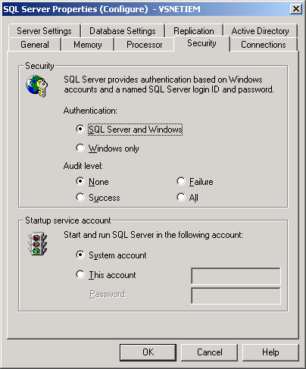
- Start the SQL Server Enterprise Manager
- Double Click on "SQL Server Group"
- Right click on the server icon in the SQL Server Group and select properties
- Switch to the Security Tab
- Under Security, Select "SQL Server and Windows" radio button for Authentication
- Press OK to accept changes. (This may cause SQL Server to be stopped and restarted but it happens automatically)
- Close SQL Server Enterprise Manager

For instructions on installing Visual Studio .NET Beta 2, please refer to the Appendix and/or the Readme file on CD 1 of Visual Studio .NET Beta 2. For up-to-date information on Beta 2 please refer to this Web site: http://beta.visualstudio.net/

Visit http://www.margiestravel.com/ for updated information on this demo and script.

2.1 Setup Instructions

2. Setup Instructions
To install Visual Studio .NET Beta 2, please refer to the Readme file on CD 1 of Visual Studio .NET and/or see the instructions in Appendix A.

2.2 Installing the Margie’s Travel Demo Overview
You will begin by installing a pre-built solution called Margie’s Travel. The Margie’s Travel solution demonstrates the use of Visual Studio .NET and the .NET Framework to create a next generation online travel site.

Margie’s Travel is a fictitious travel company that contains a database of customer profile and preference information. Margie’s Travel wants to improve their service offering by combining their existing applications with a set of XML Web services provided by other organizations in the travel industry. You will integrate XML Web services with the application to make it a real ecommerce solution.

2.3 Installing Margie’s Travel Demo Solution

Note: For this Guided Tour to function properly, you must be using Visual Studio .NET Beta 2. You must have SQL Server 7.0 or SQL Server 2000 installed and running with Mixed Security (see Section 1.1 for details). The demo is setup for the user to be logged on to Windows as Administrator, if you are not logged on as Administrator; you need to be in the Administrator group. Make sure you have IIS and SQL Server running before you begin setup.

- Copy the MargiesTravelSetup.msi to the root of your C: drive
- Execute MargiesTravelSetup.msi (Double-Click)
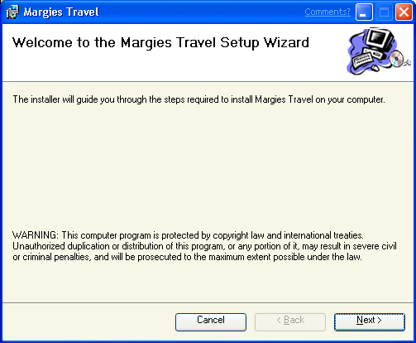

- Click Next (Welcome to the Margie’s Travel Setup Wizard)
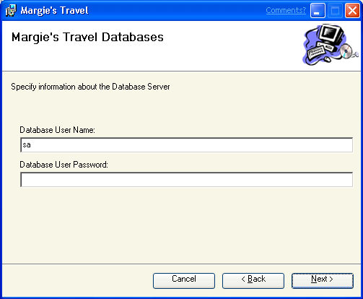

- Specify the Database Server connection information and click Next
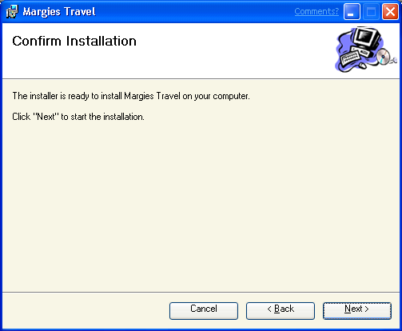

- Click Next (Confirm Installation)

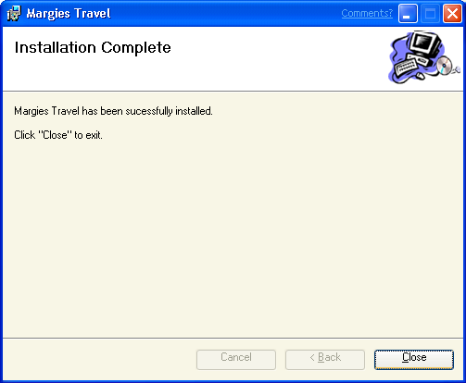

- Click Close (Installation Complete)
Now is a good time to do a basic test of the Web site with the following link to make sure Margie’s Travel is working. If the main page appears, you are ready to begin.
- Open a new instance of Internet Explorer and type in the following URL:
Http://localhost/MargiesTravel/index.aspx
- Close the Internet Explorer Window

Getting the code Snippets copied to the ToolBox
The guided tour uses code snippets that you will be copying to the code windows of application. To get these snippets into your toolbox we will be running a macro in the IDE section to do this task. It is a two step process. The first step is to copy the snippets.xml file to the C:\ root directory of your system. The second part will be to run the Margies Travel Snippets macro as part of section 4.8 of the guided tour.
- Open the [Program Files]\MargiesTravel directory from the File Explorer
- Copy the Snippets.xml file to the c:\
It needs to be in the root directory on c:\ for the macro to run

3.1 Overview of Margie’s Travel

3. Margie’s Travel demo Overview
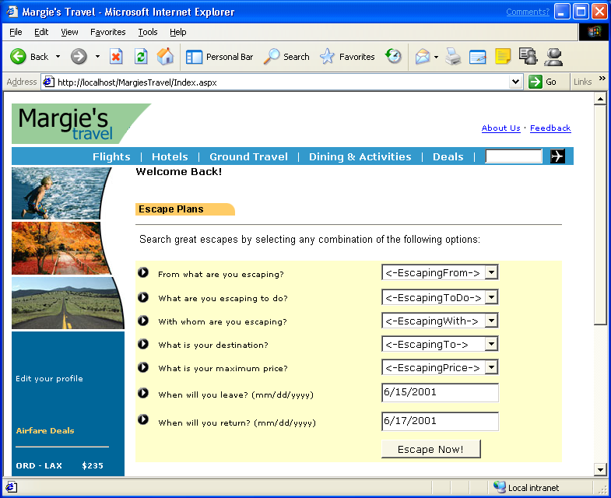
Margie’s Travel is a fictitious travel company that contains a database of profile and preference information about their existing clients. The Margie’s Travel Web site combines this information with XML Web services provided by other organizations in the travel industry to present a single Web site to handle all of their clients’ travel needs.

To plan a trip, the Margie’s Travel customer first provides some basic information about the trip they want to take. These options can include such information as what they are escaping from (work or city life), who they are escaping with (significant other, friends, family, etc), what they would like to do, etc. The Margie’s Travel site uses these choices in combination with information from the customer’s profile to recommend travel destinations and activities for the customer. Clicking the “Escape Now!” button will take you to the Travel Options page.

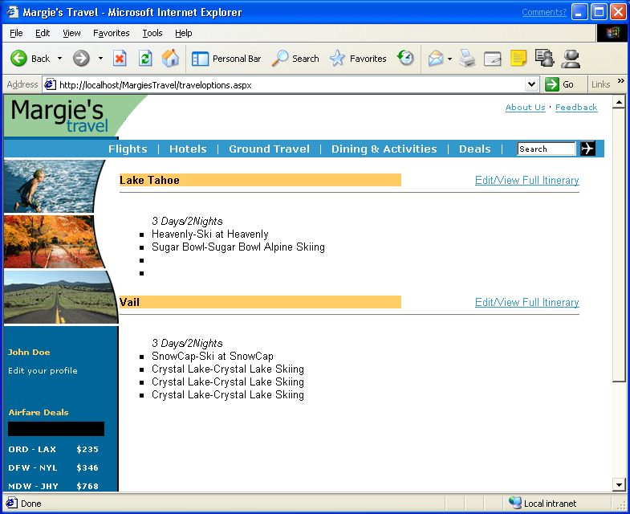
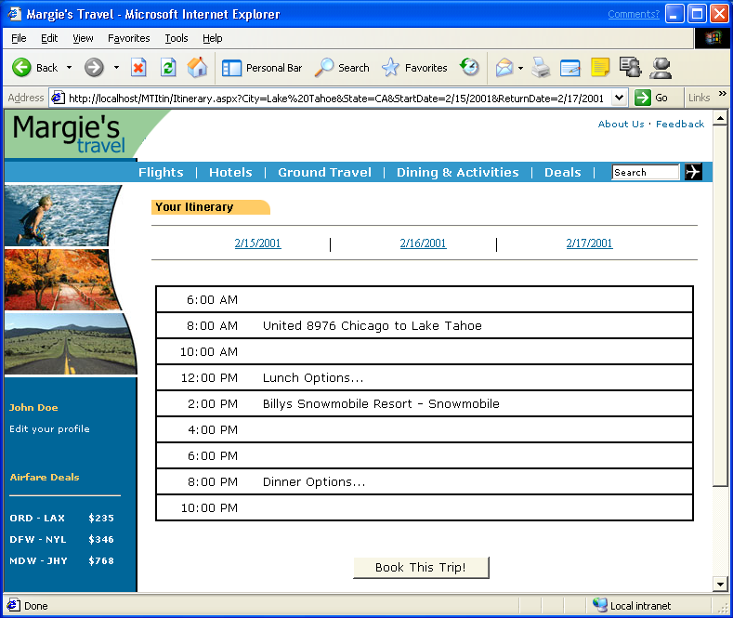
The Travel Options page presents the customer with a list of travel destinations that match their preferences as well as a few of the interesting highlights of that vacation. The user selects View/Edit Full Itinerary and is presented with a detailed daily itinerary of activities that the Margie’s Travel Web application has assembled for them.
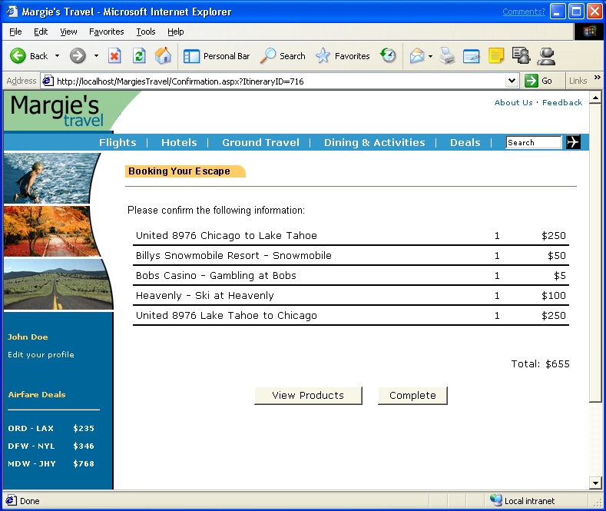
After reviewing this information, the customer can choose “Complete” to complete the reservation. Today, “Complete” merely instructs users to call Margie’s Travel to complete the booking. Selecting the View Products button will take you to a blank page with a single button, this is the page you will be building. You will use Visual Studio .NET to turn this into a real ecommerce application, and use XML Web services to create additional points of integration between Margie’s Travel and its business partners.

3.2 Margie’s Travel Application Architecture
Margie’s Travel consists of three Visual Studio .NET Solutions.

- Margie’s Travel Web Application (MargiesTravel)
- XML Web services
  - Points of Interest (developed in C#)
  - Lodging (developed in Visual Basic)
  - Airline (developed in ATL C++)
  - Credit Card (Visual Basic Application) [You will create this in the introduction section and embellish it in the advanced section]
  - Products (developed in C#) [You will create this]
- Internal Travel Agent Application (Visual Basic Windows Form application)
As an exercise, you will be building the Products XML Web service which will return information about travel related products. Using this XML Web service, the Margie’s Travel Web application will present the customer with a list of products related to their vacation destination and activities. The Credit Card Service will initially be a simple “If Then” stub that will return “Approved” or “Denied” based upon the number passed to it. In the advanced section we will replace the stub service with a C++ COM object that performs real credit card validation.

3.2 The Flow of the Margie’s Travel Demo

The following steps will give you more details on what you will be doing for the Guided Tour.

Basic
- Examine the new features of the Integrated Development Environment
- View the Margie’s Travel Web site as it exists today
- Build the simple Credit Card Check XML Web service in Visual Basic
- Test the Web service you built with a dynamically generated test page
- Add some user interface elements to the confirmation Web page, add a reference to the XML Web service you built and call the XML Web service from confirmation Web page
- Build a Windows Form application, add some user interface elements and call the Credit Card Check XML Web service you built
Enterprise and Advanced
- Design, build and test a Products XML Web service in C# that gets new product data from a SQL Server database
- Call the Products XML Web service from the Products page of Margie’s Travel
- Inherit an existing Windows Form application from the Travel Agent application, add a menu, and set anchoring for a button you build
- Embellish the simple credit card check function you built in the introduction section to call an existing ATL COM component that does a real credit card validation, this component has been wrapped in managed C++ code so you can call it from Visual Basic
Before we go through the Margie’s Travel application, let’s take a quick tour of Visual Studio .NET and examine some of its exciting new productivity features of the Integrated Development Environment.

4.1 New Features of the Visual Studio .NET IDE

4. The integrated Development environment
Visual Studio .NET has a new, customizable shell that brings Visual Basic, Visual C++®, and C# development tools into a common Integrated Development Environment (IDE). Because Web development is a key scenario in Visual Studio .NET, the functionality originally found in the Visual InterDev® Web development system is now a core part of the environment itself and is accessible from the various language products. Regardless of the language chosen for development, there is now just one environment to learn, configure, and use. You don't have to switch back and forth between environments to build, debug, and deploy your code. The result is faster, easier development of enterprise applications.
In addition, the common IDE provides end-to-end debugging of Web applications across languages, projects, processes, and stored procedures.
Whether you're building single language applications or creating mixed-language solutions, the common IDE supports high productivity development via drag and drop visual designers for HTML, XML, data, server-side code, and more. Let’s go ahead and start Visual Studio .NET Beta 2.

- Start Visual Studio .NET from the Start | Programs | Microsoft Visual Studio .NET 7.0 | Microsoft Visual Studio .NET 7.0
These first tasks are just basic familiarization with Visual Studio .NET and the new IDE.

4.2 Start Page
In order to find the right information at the right time from the MSDN® library, the Visual Studio .NET IDE can now display links to related documentation (including MSDN Magazine articles) based on the features or technologies currently in use. For example, if you're in the IDE but don't have an application or component open, the environment displays links to information on how to plan an application, a selection of common business templates and wizards, and a dynamic list of application templates from various vendors. As you progress through the creation of your application, the IDE knows what part of the application you are working on and displays appropriate content in the Dynamic Help window.

4.3 Customizing the IDE
- If this is your first time running Visual Studio .NET
  - Select the dropdown menu from the My Profile and pick Visual Basic Developer
If you have run Visual Studio .NET before you will not see the Profile screen when you first start Visual Studio .NET
  - From the main start page above, Click on the My Profile link on the left hand side of this page.
  - Select the dropdown menu from the Profile and pick Visual Basic Developer. If Visual Basic Developer is already selected, point out the other options available for the Profile, but leave selection as Visual Basic Developer.
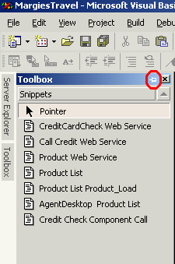
- Click on the Get Started link to return to the project home page
- To toggle the “Auto Hide” feature of the Toolbox, click on the Toolbox label in the far left side of the IDE and click on the little Punch Pin (highlighted in circle at the left, hard to see) on the top of the toolbox right next to the X (close window of the toolbox). Move the cursor away from the toolbox. If “Auto Hide” is on, the toolbox will disappear. If it is off the toolbox will remain in position. If necessary, click the Punch Pin again to ensure that the “Auto Hide” feature is on.
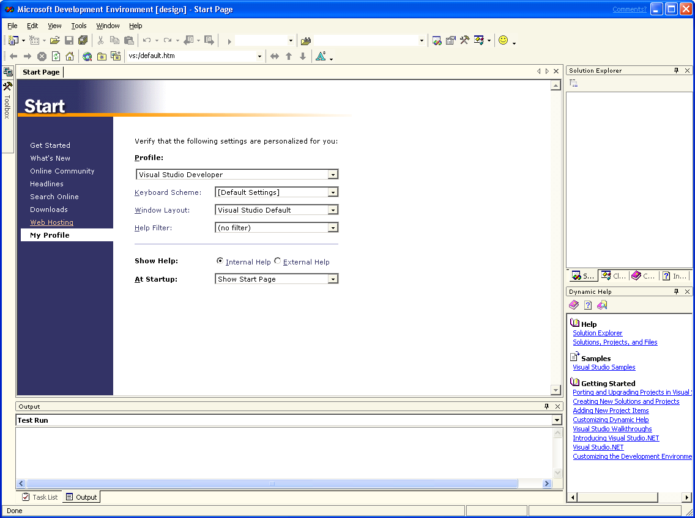
NOTE: At this point in the exercise, you might not have a code snippets tab within your toolbox, but the “Auto Hide” feature works when any tab is selected.

4.4 Solution Explorer
The Solution Explorer displays an organized list of all the projects as well as their corresponding files and directories that are part of the current solution. A solution consists of projects, which can be in different programming languages. Since the Visual Studio .NET project system is file-based, opening a directory from within the tool automatically loads all of the relevant files under the directory into the selected project. The Solution Explorer provides developers with an intuitive view of all files in a given project, saving time when editing multiple file projects.
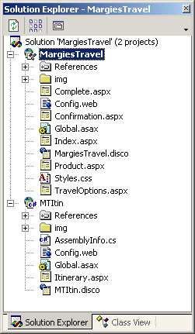
- From the menu select File | Open Solution… and navigate to
[Program Files]MargiesTravel\WebSite
- Select MargiesTravel and click Open
- The Solution Explorer is a window on the right side, top area of Visual Studio .NET
- At the top of the Solution Explorer window click on the Show All Files button (2nd one from the left)
NOTE: This will show you the Web pages and the code behind the Web page if it has one.

4.5 Dynamic Help
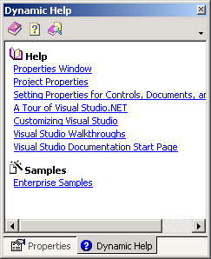
The Dynamic Help window provides one-click access to pertinent help regardless of the task a developer is attempting to complete. By tracking the selections a developer makes, the placement of the cursor, and the items in focus within the IDE, Dynamic Help filters through topics available on MSDN and provides pointers to relevant information specific to the current development task at hand.

For this task you will be clicking on a dynamic help topic and seeing the results in the main window.

- To activate Dynamic Help, click on the Dynamic Help link/tab at the lower bottom right of the screen, under the properties window.
- Click on the first link in the Dynamic Help window
Solution Explorer
- From the menu (i.e. File, Edit, View) Select Help | Show Start Page (wait until you see the help text in the main window)
Now you know how to use the Visual Studio .NET help system. The Help system is context sensitive, i.e. Web Forms versus Windows Forms programming. It knows your profile based on what you have selected for your profile information.

4.6 Task List
The Task List feature, formerly available only to developers working in Visual InterDev and Visual J++® development systems, now works across all Visual Studio-based languages and projects and allows developers to mark their code with comments related to tasks they need to do. These tasks are parsed and displayed in an easy tabular format in the Tasks window. This feature makes it easy for you to annotate your code so that when you or another member of your team opens it later, the exact state of the code can be understood. Double-clicking on the comment in the Task List displays the section of code containing the comment.

- Double click on the Product.aspx file in the Solution Explorer
- To view the Task List - From the menu, Select | View | Other Windows | Task List
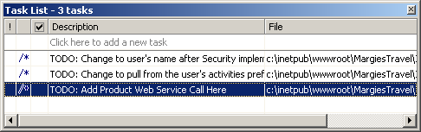
- You should see the tasks show up in the Task List at the bottom of your screen.
NOTE: To see the window completely you may have to scroll the horizontal bar that separates the Task List and the code window above it.
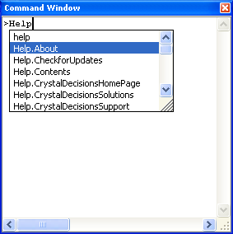
- Double click on the task labeled TODO: Add Product XML Web service Call Here (should be on the bottom of the Task List) it will take you directly to the place in the code where that item exists
NOTE: If you don’t see the tasks in the task list, you have filtering on. To turn off filtering, right mouse-click on the on a task and select Show Tasks | All

4.7 Command Window
The Command Window enables you to harness the power of the IDE by providing a single input line to find, navigate, and execute the many possible elements within and outside the IDE (its scope is the full set of commands in Visual Studio). If you prefer the keyboard, you can use the Command Window as a method to perform searches, navigate to windows and items within a solution, execute commands, navigate the Web, and run external programs. The IDE's IntelliSense® feature has been extended to the Command Window where it suggests a match based on entries you have typed previously. You can recall previously entered commands by using the up arrow, similarly to a command prompt in Windows. Some commands take parameters to bypass the user interface and dialogs (saving time) and some even offer completion on the parameters themselves. (For example, the File.OpenFile command offers completion for the file name you want to open.)

- To view the Command Window - From the menu, select View | Other Windows | Command Window
- You will see the command window at the bottom of your screen
- Select the Product.aspx tab at the top of your code window
- Click the HTML tab at the bottom left of the code page
  - HTML view is a tab at the bottom of the code page that lets you switch between design mode and HTML code.
- Type Help in the Command Window and delete what you just typed. If you pressed enter, close that window from the projects tab
Notice the Intellisense in the command window.
- Type gotoln 100 in the Command Window and press Enter
(this will take you to line 100 in the page)
- Type gotoln 1 in the Command Window and press Enter
(this will take you to line 1 in the page)
Notice that the focus will remain in the Command Window and when you switch to the editor by clicking the Products.aspx tab, the cursor in the editor will be placed on the specified line.

4.8 Macros
The IDE is now completely customizable and extensible using Visual Studio Macro (VSM) macro recording and programming. Almost the entire range of IDE sub-systems are available for customization and automation. The addition of VSM support simplifies the process of integrating other tools or applications (such as Microsoft Project or the Outlook® messaging and collaboration client) into the development cycle. On-the-fly customization and invocation of macros can be coded in the Command Window for an additional level of control.

The following task is required for the rest of the demo to work. You cannot skip this task. This task add a new macro project (MargiesTravel.macros) to your system. Once the macro is installed, you will execute it and it will copy the snippets.xml file that you should have placed in your c:\ directory from [Program Files]\margiestravel in step 6-7 of Section 2.3.

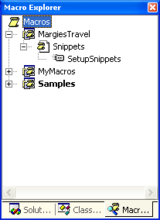
- To view the Macro Explorer - From the menu, Select View | Other Windows | Macro Explorer (it’s the top one)
- From the menu select File | Open | File… and browse to
[Program Files]\MargiesTravel\
- Select MargiesTravel.vsmacros and click Open
It will show up as project node in the Macro Explorer (see image to the left)
- In the Macro Explorer window as shown at the left, navigate the tree of MargiesTravel – and expand Snippets module as seen to the left
NOTE: DO NOT double-click on Snippets
- From the Macro Explorer window double-click on SetupSnippets macro (it will take 10 seconds to run)
NOTE: The Visual Studio .NET IDE will SHUT DOWN when you run this macro, this is expected. Next you will Start Visual Studio .NET and look for the code snippets.

- Start Visual Studio .NET from the Start | Programs | Microsoft Visual Studio .NET 7.0 | Microsoft Visual Studio .NET 7.0
- From the menu select File | Open Solution… and browse to
[Program Files]\MargiesTravel\WebSite
- Select the MargiesTravel.sln and click the Open button
- Double click on confirmation.aspx from the Solution Explorer (you need to have a page up so the snippets tab will be visible)
- Open the Toolbox on the left side of your screen and look for the Snippets tab, you should see 8 code snippets
- Exit Visual Studio .NET by select File | Exit
NOTE: If it asks you to save changes, select No

4.9 Summary
Visual Studio .NET sports a brand new integrated development environment (IDE) – a single shared environment for all the languages within it! It was designed to help developers build their solutions faster with less clutter and with all of the tools easily accessible in any of the Visual Studio languages. Completely customizable, the Visual Studio .NET IDE has a host of features that show developers information when they need it and how they want it. We have just seen a few of the main features of the IDE, we will see others throughout the guided tour.

5.1 Margie’s Travel – The Current Web Site - Walkthrough

5. Margie’s Travel
The Margie’s Travel Web site as it exists today has some functionality but requires the customer to phone the Call Center to book the actual travel. The Web site will make extensive use of profile information and suggest places of interest that the customer might want to visit. Once the customer finds out what they want to do, they are instructed to call the Travel Agent Call Center so they can book the hotel and airline. In this Tour, we’ll add the functionality to complete the transactions to make this a real ecommerce application.
Let’s first go through the application, as it exists today.

- From Internet Explorer Browser, Enter this URL
http://localhost/Margiestravel/index.aspx
- From the “From what are you escaping” dropdown menu Select Work
- From the “What are you escaping to do?” dropdown menu Select Skiing
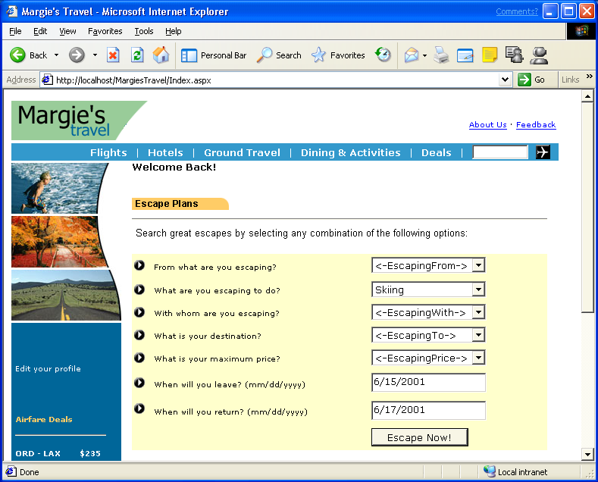
- Click on the button at the bottom labeled Escape Now!
You will see the page below containing information about travel destinations that meet your preferences and profile information.

- Click on the Edit/View Full Itinerary button at the top right
You should see the screen below, which gives your itinerary information. Let’s go ahead and book this trip.
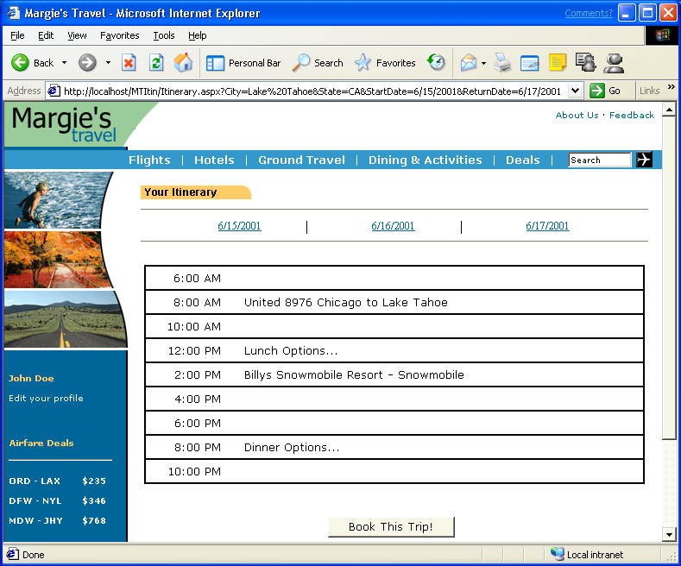

- Click the Book This Trip! button

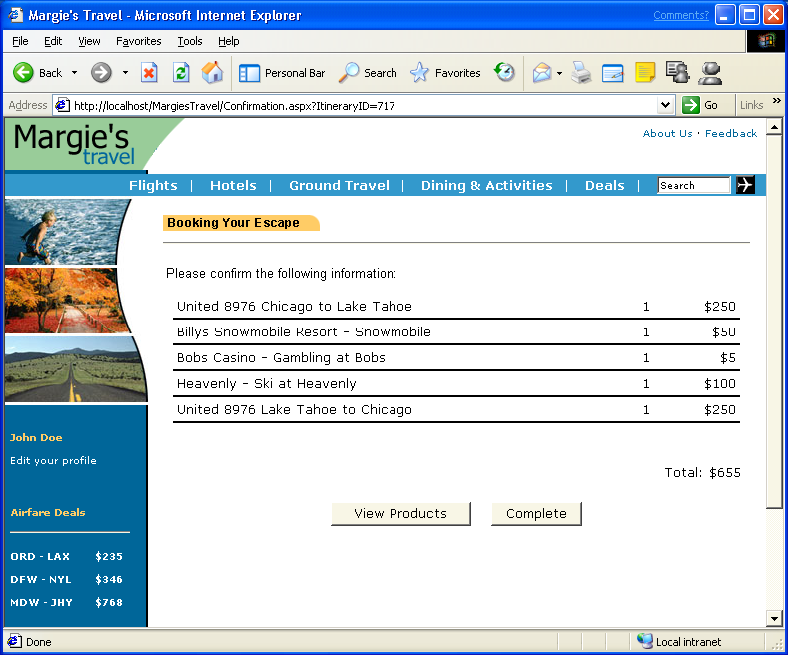
This is your itinerary with prices for the Airlines, Hotel and Points of Interest and a total cost for the trip you will be booking. You can either view some products related to your transaction or complete this transaction.

- Click the Complete button

After you click on the “Complete button”, you will get the confirmation page below.
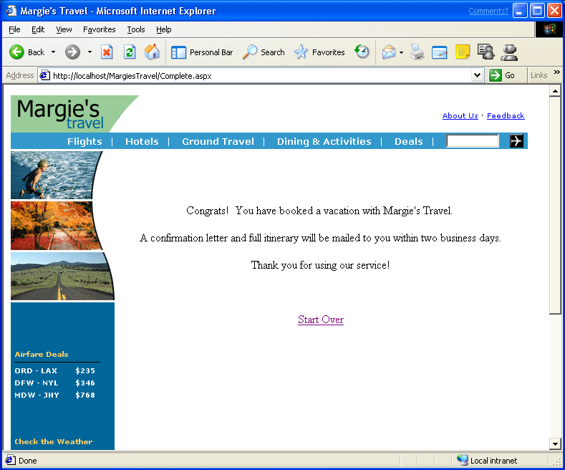
- Exit Internet Explorer and return to the Desktop

5.2 Summary
You have just completed a walk through for the Margie’s Travel Web site as it exists today. The next step is to add functionality to the site by creating new XML Web services and then authoring code to integrate the new services.

6.1 Creating your XML Web service

6. Creating And calling your first web Service
We are going to create a simple credit card checker XML Web service in Visual Basic and call that XML Web service from the Margie’s Travel Web Application. The XML Web service will do a basic Credit Card validation. In the Advanced section, we will add a real Credit Card validation component to this function.

- Start Visual Studio .NET from the Start | Programs | Microsoft Visual Studio .NET 7.0 | Microsoft Visual Studio .NET 7.0
- Select File | New | Project…
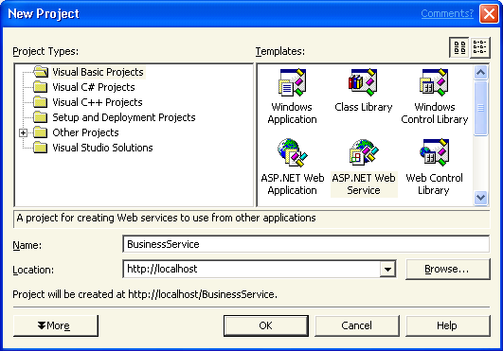
- From the left pane, ensure that Visual Basic Projects is selected, from the right templates pane, select ASP.NET Web service
- Type in BusinessService for the Name: of the XML Web service Project as shown above, click OK
NOTE: You will notice that the screen shot has http://Localhost in the Location: field. You might see your servername in that field and that is fine or you can type http://Localhost, both will work fine.
- From the menu at the top of your screen, select Project | Add Web service

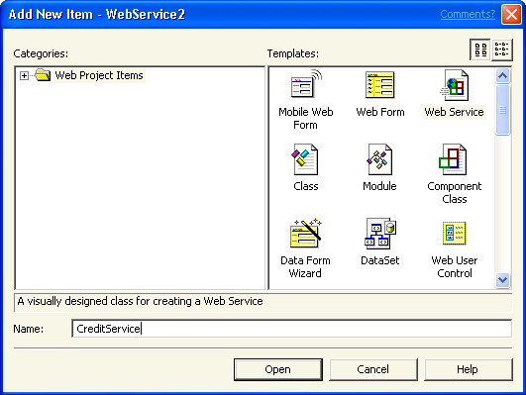
- Type in CreditService for the name of the new XML Web service, click Open (see above picture)
- You will be taken to the design surface of the CreditService, right mouse-click on the empty space on the design surface and select View Code from the pop-up menu. Scroll down to the bottom of this code Window
- Place your cursor after End Function of the HelloWorld Function and press Enter a few times (the cursor needs to be below the Function in the whitespace)
'<WebMethod()> Public Function HelloWorld() As String
' HelloWorld = "Hello World"
' End Function
|
- On the left side of your screen, click on vertical tab called Toolbox, click on the Snippets tab
NOTE: If you do not have the Snippets tab, you need to complete the Macros Task in section 4.8 of the IDE Section at the beginning of this document.
- Double click on the code snippet from the toolbox Snippets tab titled CreditCardCheck XML Web service
- This code snippet will automatically be copied to your page

<WebMethod()> Public Function CreditCardCheck(ByVal CardNumber As String) As String

If CardNumber = "1234" Then
Return "Approved"
Else
Return "Denied"
End If

End Function

- From the Build Menu, Select Build
- View the output window at the bottom of your window and make sure the XML Web service built properly, it should read:
Build: 1 succeeded, 0 failed, 0 skipped

6.2 Testing your XML Web service
You have just built a real XML Web service. Now let’s test the XML Web service with the dynamically generated test page that the .NET Framework automatically created for us.

- From the Windows task bar, launch Internet Explorer
Type Http://localhost/BusinessService/CreditService.asmx

NOTE: Alternatively, you can also view the Web page in Visual Studio .NET by right mouse-clicking on the CreditService.asmx file in the Solution Explorer and selecting View in Browser
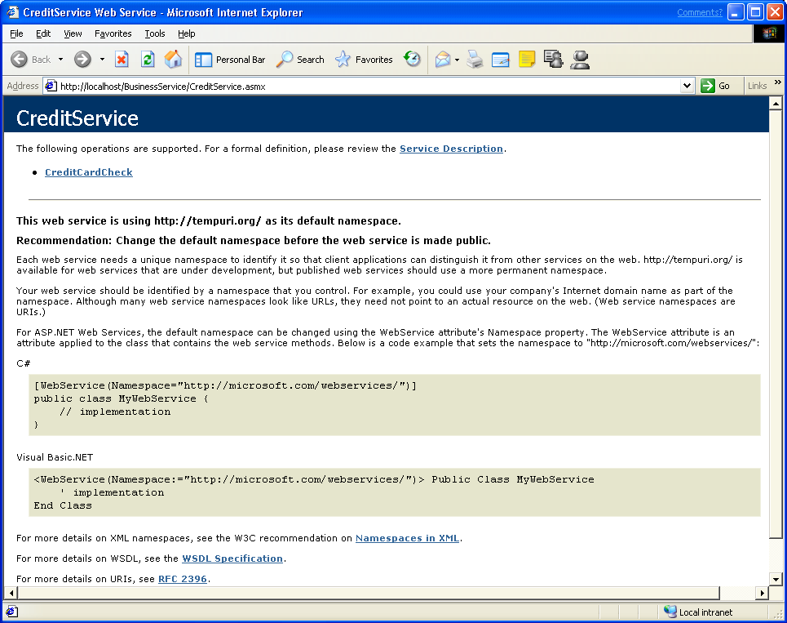
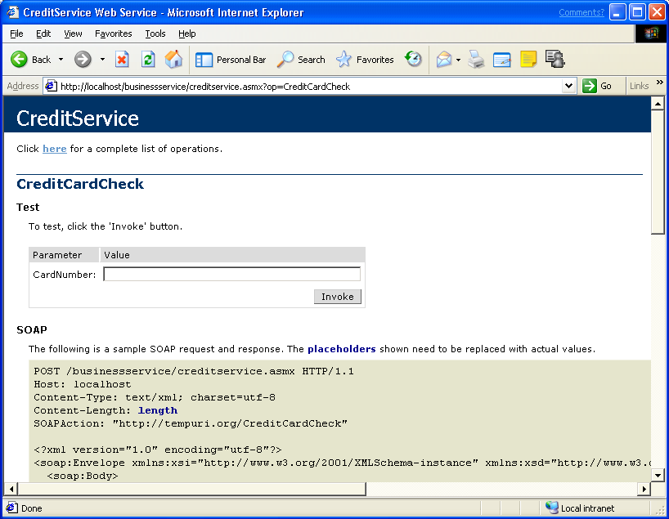
- Select the CreditCardCheck link.

- Type in 1234 into the Value text box
- Click on the Invoke button
NOTE: A new instance of Internet Explorer will open with the expected result

- You should get the following XML text back in your browser
<?xml version="1.0" encoding="utf-8" ?>
<string xmlns="http://tempuri.org/">Approved</string>

- Close both instances of Internet Explorer
- From the main menu of Visual Studio .NET select File | Exit
Congratulations! You just built and tested your first XML Web service

6.3 Calling a XML Web service from a Web Form

- Start Visual Studio .NET from the Start | Programs | Microsoft Visual Studio .NET 7.0 | Microsoft Visual Studio .NET 7.0
- From the menu select File | Open Solution… and browse to
[Program Files]\MargiesTravel\WebSite\
- Select the MargiesTravel.sln file and click the OK button

NOTE: Alternatively you can start Visual Studio .NET 7.0 and click on the MargiesTravel link on your start page to open the solution

- From the Solution Explorer, double click on confirmation.aspx to open it
- Scroll down to the bottom of the page
- From the toolbox under the tab Web Forms on the left, drag a Label control, Button, and textbox and place them after the grand total price and above the View Products and Complete button (the order or appearance doesn’t matter)
Note: You might have to hit enter a couple times to move the View Products and Complete buttons down on the page to make room for the new controls.

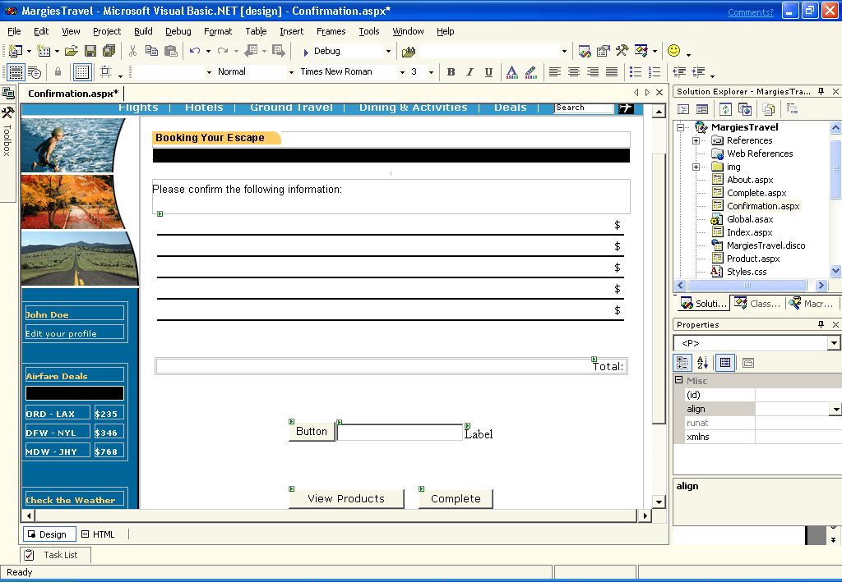
6.31 Adding the Web Reference to your Project
In order for the Web application to use the XML Web service, we need to add it as a Web reference to our project.

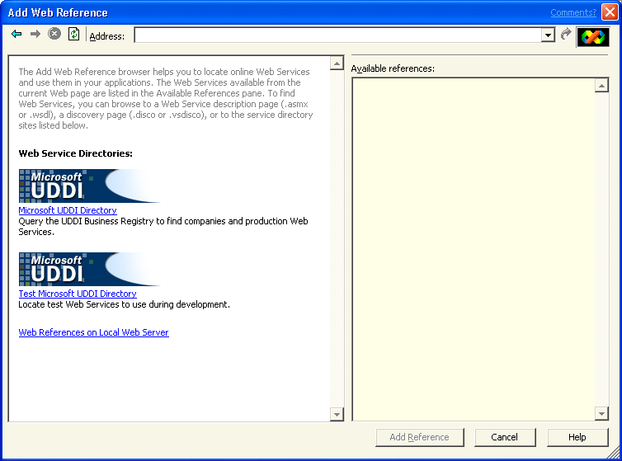
- From the main menu, Select Project | Add Web Reference
- On the left side of the screen select the link Web References on Local Web Server

Note: If you don’t see a list of Available references after clicking on the Web References on Local Web Server link, you can get the reference by typing the web service URL (http://localhost/BusinessService/CreditService.asmx) directly into the Address text box on this dialog and hitting the Enter key.
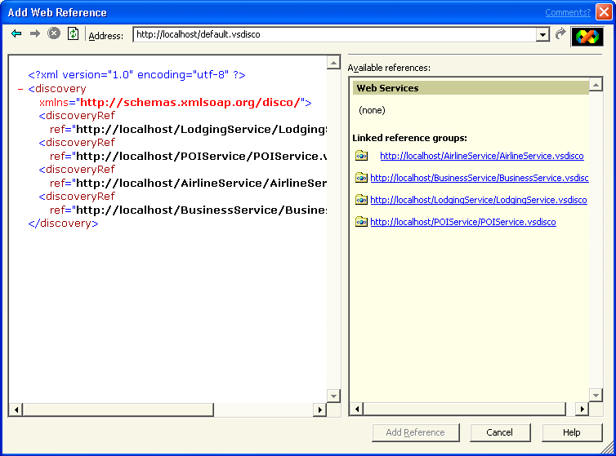
- Carefully select the correct link in the right pane of the window http://localhost/BusinessService/BusinessService.vsdisco
- Click on the Add Reference button
NOTE: You have added a Web reference to your project. Have a look in the Solution Explorer

6.32 Calling the XML Web service from your Web Form application

- On the Web Form Page confirmation.aspx that you are embellishing, double-click Button
NOTE: You’re now in the code window for the Button event

- The cursor will default on the Button1_Click event (between the Private and the End Sub)
- Double-click the code snippet from the Toolbox Snippets tab
Call Credit XML Web service
- This code snippet will be automatically copied to your page where you cursor was

Private Sub Button1_Click(ByVal sender As Object, ByVal e As System.EventArgs) Handles Button1.Click

Dim BusinessService As New localhost.CreditService()
label1.Text = BusinessService.CreditCardCheck(textbox1.Text)

End Sub

6.33 Run your Web Form Application

- From the main menu select Build | Build Solution
- You should see the following output in the output window at the bottom of your screen
Build: 3 succeeded, 0 failed, 0 skipped
- In the Solution Explorer under the MargiesTravel Project, Select index.aspx
- Right mouse-click on index.aspx and select Set as Start Page
- Press F5 to run your application
- Test it out by typing 1234 in the text box and clicking the Button
- If you get the Internet Explorer Dialog about Auto Complete, select NO
NOTE: The expected result is that the label1 now says “Approved”

- Close the Internet Explorer window
- Close Visual Studio .NET by going to main menu and select File | Exit
Congratulations, you just called your first XML Web service!

6.4 Calling your XML Web service from a Windows Form
You are now going to create a Windows Form from scratch and call the XML Web service you just wrote.

- Start Visual Studio .NET from the Start | Programs | Microsoft Visual Studio .NET 7.0 | Microsoft Visual Studio .NET 7.0
- From the Start page, Click on the New Project button
- Select Visual Basic in the left pane, and Select Windows Application in the right pane
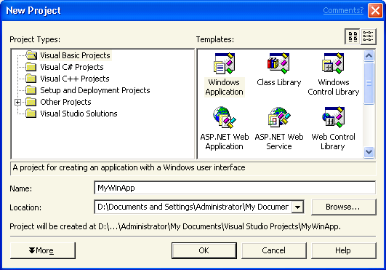
- Type in MyWinApp for the Name of the Application
- Click on OK
- From the toolbox under the tab Windows Forms on the left, drag a Label control, Button, and Textbox to the form and make it look something like the Form1 below.
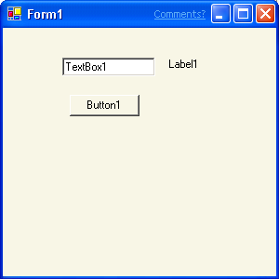

6.41 Adding the Web Reference to your Project

- From the menu, Select Project | Add Web Reference
- Select the link Web References on Local Web Server
Note: If you don’t see a list of Available references after clicking on the Web References on Local Web Server link, you can get the reference by typing the web service URL (http://localhost/BusinessService/CreditService.asmx) directly into the Address text box on this dialog and hitting the Enter key.
- Select the link http://localhost/BusinessService/BusinessService.vsdisco
- Click on the button Add Reference

6.42 Calling the XML Web service from your Windows Form application

- On the Windows Form page you just created, double-click Button1
- The cursor will default in the correct location of button1
- From the Toolbox Snippets area, double-click on the code snippet Call Credit XML Web service
Notice that this is the same code that we used to call the XML Web service from the Web Form
Dim BusinessService As New localhost.CreditService()
Label1.Text = BusinessService.CreditCardCheck(TextBox1.Text)

6.43 Run your Windows Form Application

- From the menu select Build | Build
- You should see the following output in the output window at the bottom of your screen
Build: 1 succeeded, 0 failed, 0 skipped

- Press F5 to run your application
- Type “1234” into the text box and click Button1 to test your application (you will see Approved where the label was)
- Close the Windows Application by clicking on the X close box
- Close Visual Studio .NET, from the menu select File | Exit
Congratulations! You just built a Windows Application and called your XML Web service!

6.5 Summary
In this first exercise you have accomplished a lot. You have:

- Created a XML Web service to check Credit Card numbers
- Tested your XML Web service with the dynamically generated test page
- Modified a Web application to call a XML Web service
- Created a Windows application to call a XML Web service
This section examines advanced features in Visual Studio .NET for designing and testing XML Web services as well as providing architectural guidance for developers.

7. Enterprise Scenario

7.1 ORM Database Design
This exercise shows how business rules can be captured using simple to understand statements and directly used to implement the database design. The benefit is that non-technical business domain experts can now assist in the database design process, ensuring that the business rules and requirements are accurately captured. The database modeling features shown here are based upon Visio, an easy-to-use and powerful diagramming tool.
- Start Visio from the Start | Programs | Microsoft Visio
- From the menu select File | Open… and browse to [Program Files]\MargiesTravel\EnterpriseFeatures\ ORM DB\
- Select the Product Example.vsd file and click the Open button
- If the Business Rules window is not visible at the bottom of the screen, From the menu select Database | View | Business Rules
- Add a new Fact Type by Double-clicking on the row in the Facts table that says (Double-click here to add a new fact type).
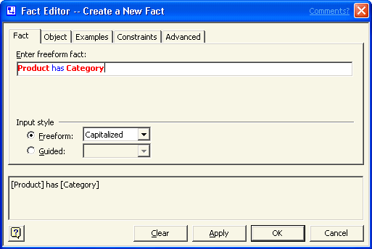
- In the Fact Editor, set the Input Style = Freeform and enter the new Fact Type like the image below.
Note: It is important that “Product” and “Category” are capitalized because this is how the tool indicats an object
- Still in the Fact Editor, select the Constraints tab and specify that a Product can have one or more Categories by selecting the appropriate option from the drop down box (see the image below)
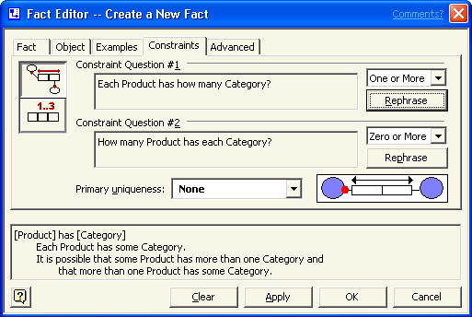
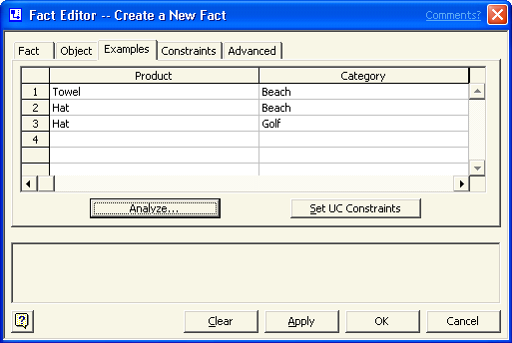
- Still in the Fact Editor, select the Examples tab and enter the following example facts:
- Still on the Examples tab, click the Analyze button to verify that the examples and constraints are set correctly.
Note: This is a powerful feature that enables a business analyst or database designer to fine tune the business rules to exactly meet the requirements.
- Click the Close button to close the Analysis Results window
- Click the OK button to save the changes and close the Fact Editor
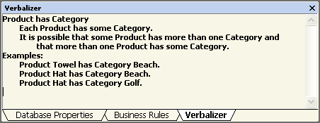
- Select the Fact “Product has Category” (should be selected by default) and from the menu select Database | View | Verbalizer
Note: The exact business rule is specified along with the sample data so that someone who understands the business requirements can easily verify for correctness.
- Select the Business Rules tab again and drag the new Fact Type onto the diagram placing it between the Product (SKU) and Category (ID) objects. Now the rule that was just created is also reflected in the visual diagram.
Note: To drag the Fact Type, click on description (Product has Category) not the Predicate symbol in the left most column.
- From the menu select File | Exit to close Visio
NOTE: If asked to save changes, select Yes

7.2 Class Modeling
In this section we will use the new UML modeling tools that are part of Visual Studio .NET Enterprise Architect to model an Inventory component to access the product information in our database. Software modeling helps to capture the architecture and functionality of an application and communicate it across a team of developers. The software modeling features shown here are based upon Visio, an easy-to-use and powerful diagramming tool.
- Start Visio from Start | Programs | Microsoft Visio
- From the menu choose File | Open… and browse to [Program Files]\MargiesTravel\ EnterpriseFeatures\Class Model\
- Select the Inventory Class.vsd file and click the Open button
- Right-click on the Inventory object and choose Properties
- Select Operations in the left-hand side Categories list
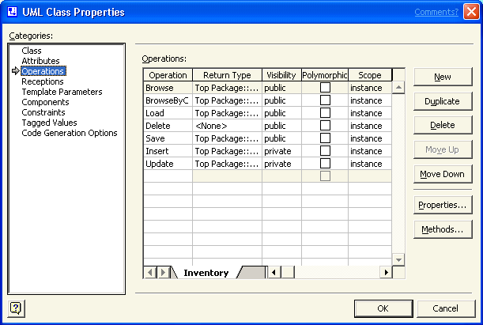
- Click the New button to add a new operation to the Inventory class.
- With operation1 selected (should be by default) click the Properties button
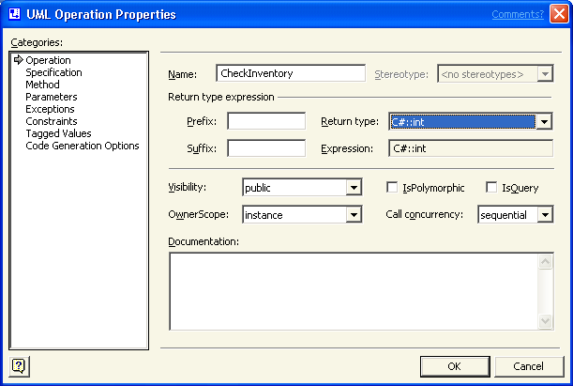
- Set the Operation Properties like the image below. Specifically change the name of the Operation to CheckInventory and set the Return Type to C#:int
- Still in the Properties Dialog, Select the Parameters category from the left-hand side of the dialog
- Click the New button to add a new Parameter to this operation
- With the Parameter1 row selected (should be by default) click the Properties button
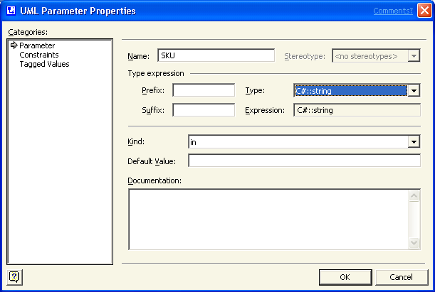
- Set the Parameter properties like the image below. Specifically, set the Name of the parameter to SKU
- Click the OK button to save the changes to the Parameter
- Click the OK button to save the changes to the Operation
- In the UML Class Properties dialog, select Code Generation Options from the left-hand side Categories list
- Click the Preview Code button to see the C# code that will be generated for this new class, making it easy and accurate to get started coding the method’s functionality
- Click Close to close the Code Preview window
- Click OK to save the changes to the Inventory Class
- Close Visio, from the menu select File | Exit
NOTE: If asked to save changes, select Yes

7.3 Products XML Web service – Architectural Guidance
Let’s create the Products XML Web service and call it from the Products Web page. When we build the Products XML Web service, we will be connecting to a SQL Server 2000 database to get the data we need for our new XML Web service. To help us build this new XML Web service, we will use an Enterprise Template project that provides additional architectural guidance for building the components of an Enterprise application. The Enterprise Template project contains guidance, best-practices, and policy that can be created by an architect to help developers make the right choices when building an application.

- Start Visual Studio .NET from the Start | Programs | Microsoft Visual Studio .NET 7.0 | Microsoft Visual Studio .NET 7.0
- From the menu select File | New | Project…
- Select Other Projects | Enterprise Template Projects | Visual C# Building Blocks from the left pane and Data Access from the right pane

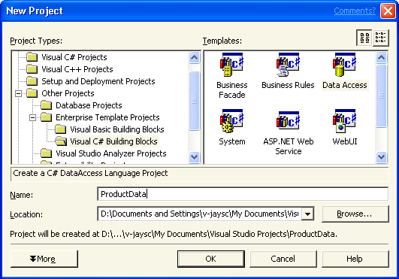
- Type ProductData as the Name of the new project and click the OK button
- From the menu select Project | Add Component
Note: Notice that the Enterprise Template policy has disabled the Add Windows Form, Add Inherited Form, Add User Control, and Add Inherited User Control menu options so that we do not add an incorrect item. This is one of the default policies included with the Enterprise Template projects for a Data Access component. These policies and projects are completely customizable and extensible, enabling organizations to tailor the guidance to their unique requirements.
- Type ProductDC as the name of the new component
- Click the Open button
- From the toolbox Data tab, Drag OleDbDataAdapter from toolbox on the design surface
Visual Studio .NET will invoke the Data Adapter Configuration Wizard
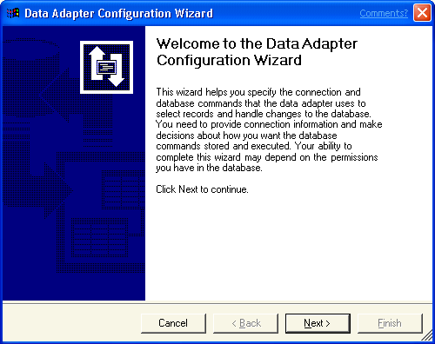
- Click Next button
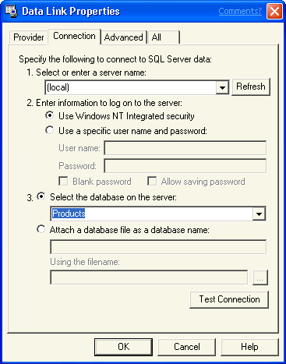
- Select Products.dbo from the dropdown and skip to step 47. If it does not exist in the dropdown, continue from step 44.
- Click the New Connection… button
- Enter these 3 values in the Data Link Properties (as shown on the left)
Server Name=(local)
Use Windows NT Integrated security
Database on the Server = Products
- Click OK
- Click Next
- Select Use Existing Stored Procedures, click Next
- Select Product_Browse in the “Select” drop down menu
- Click the Finish button
- Right-click on the ProductDC.cs [Design] and choose View Code from the menu
- Scroll to the bottom of the page
- Place the cursor below the line below as seen here
//
// TODO: Add any constructor code after InitializeComponent call
//
}

- From the Toolbox Snippets Tab, double click Product Data Access code snippet, the code will be placed where the cursor was in your code window
public System.Data.DataSet Browse()
{
//Query the DB and return the product information
System.Data.DataSet products = new System.Data.DataSet();

this.oleDbDataAdapter1.Fill(products);

return products;
}

- From the Build Menu, Select Build
- You should see the following output in the output window at the bottom of your screen
Build: 1 succeeded, 0 failed, 0 skipped
- From the menu, select File | Add Project | New Project…
- Select Other Projects | Enterprise Template Projects | Visual C# Building Blocks from the left pane and ASP.NET Web service from the right pane
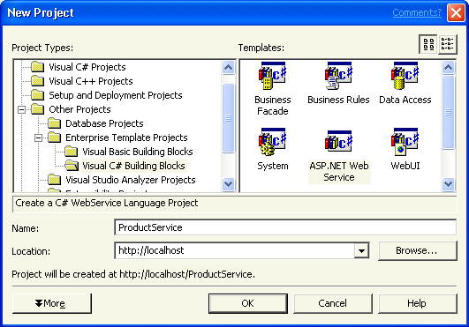
- Type in ProductService for the name
- Click the OK button
- From the Project menu, Select Add Reference…
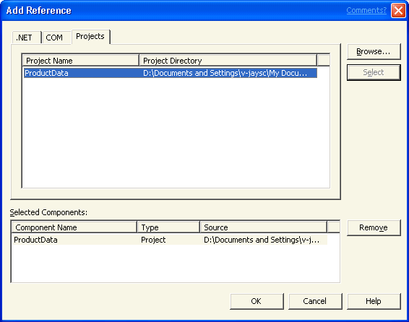

- Select the Projects tab
- Select the ProductData Project, then click the Select button
- Click the OK button
- From the Project menu, Select Add Web service
Note: Notice that the Enterprise Template policy has disabled the Add Web Form and Add Web User Control menu options so that we do not add an incorrect item.
- Type in Product as the name and click Open
- Right click on the Product.asmx.cs [Design] surface and choose View Code from the menu.
- Scroll to the bottom of the page
- Place the cursor above the line below as seen here
|
//WEB SERVICE EXAMPLE
- From the Toolbox Snippets Tab, double click Product XML Web service code snippet, the code will be placed where the cursor was in your code window
[WebMethod]
public System.Data.DataSet Browse()
{
// Call the DataAccess assembly and return the data
ProductData.ProductDC product = new ProductData.ProductDC();
return product.Browse();
}

- From the Build Menu, Select Build Solution
- You should see the following output in the output window at the bottom of your screen
Build: 2 succeeded, 0 failed, 0 skipped
- Let’s use the dynamically generated test page to test our XML Web service
- Launch Internet Explorer and type http://localhost/productservice/product.asmx
- Click the Browse link
- Click on the Invoke button (no parameters need to be entered)
- A new instance of Internet Explorer will appear with the results from SQL Server
NOTE: You will see the data coming back as pure XML

- Close both instances of Internet Explorer
- Close Visual Studio .NET, from the menu select File | Exit

7.4 Testing the Products XML Web Service
Now that we have a working web service, we will take advantage of the Application Center Test (ACT) integration wit h Visual Studio .NET to perform a series of load and functionality tests on our web service. This will ensure that the application performs the functionality as intended and can handle the volume of use expected of it.

7.4.1 Load Testing
- Start Visual Studio .NET from the Start | Programs | Microsoft Visual Studio .NET 7.0 | Microsoft Visual Studio .NET 7.0
- From the menu choose File | Open Solution… and Browse to [Program Files]\EnterpriseFeatures\ACT\
- Select the Margies Travel Tests.sln file and click the Open button
- In the Solution Explorer, double-click the Product Load Test.vbs
This will open the pre-recorded ACT test script.
- In the Solution Explorer, select the Product Load Test.vbs file again
This will open the properties window for the Load Test script
- In the Properties Window, change the RunTime property to “60”
Note: The RunTime property specifies the length of time (in seconds) that the test will run.
- Still in the Properties Window, change the Connections property to “5”
Note: The Connections property specifies the number of client connections that will be simulated during the test
- In the lower left-hand corner of the IDE select the Output Window tab
- In the top right corner of the Output Window, click the pushpin to turn off the auto-hide feature and keep the window visible.
- In the Solution Explorer, Right-click on the Product Load Test.vbs file and choose Start Test
In the Output window you should see the progress of the test while it is running. Notice that while the test is running you can continue to work within the IDE, but you must wait until the load test completes before starting another ACT test.
- Close the Product Load Test.vbs file

7.4.2 Functionality Testing
- In the Solution Explorer, double-click on the Product Functionality Test.vbs file
- Scroll down in the script file until you find the '---ADD CODE BETWEEN HERE--- comment
- Place your cursor between the comments
- Double-click on the Functionality Test snippet in the toolbox to add the following line of code
Test.Trace(vbcrlf & "Result Code: " & oResponse.ResultCode & vbcrlf & "Valid Response: " & IsStringInResponseBody(oResponse, "Product_Browse1") & vbCrLf)
- Choose the File | Save All menu to save the changes
- In the Solution Explorer, right-click on the Product Functionality Test.vbs file and choose Start Test
Note: This test will run quickly since we are only making a single call to the XML Web Service.
- Choose the File | Open | File menu option and browse to the [Program Files]\Microsoft ACT\ACTTrace.log file and choose Open
- Review the results of the test
- Close Visual Studio .NET

7.5 Calling the Products XML Web service from the Products Web Page

100. Start Visual Studio .NET from the Start | Programs | Microsoft Visual Studio .NET 7.0 | Microsoft Visual Studio .NET 7.0
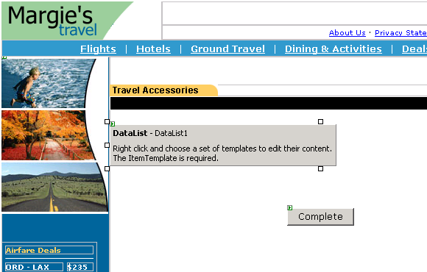
101. Open the Margie’s Travel solution by clicking the MargiesTravel link on the Start Page
102. Open Product.aspx in Design view, by double-clicking on the Product.aspx item in the Solution Explorer
103. From toolbox | Web Forms, drag a DataList control onto the form (below the Travel Accessories header and above the Complete Button, as shown at the left)
104. Right click on the DataList and choose Edit Template | Item Templates
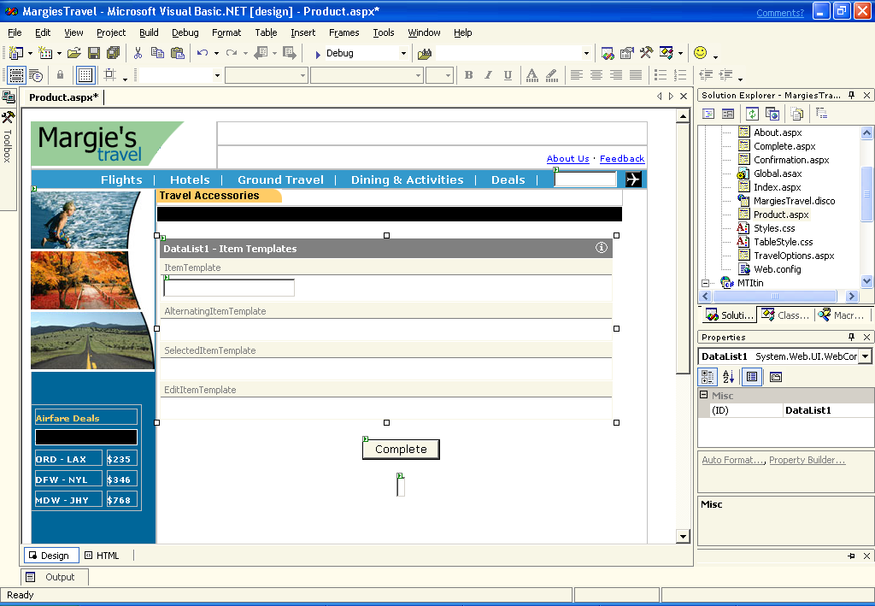
105. Size it to the width of the page (optional, but makes it look better)
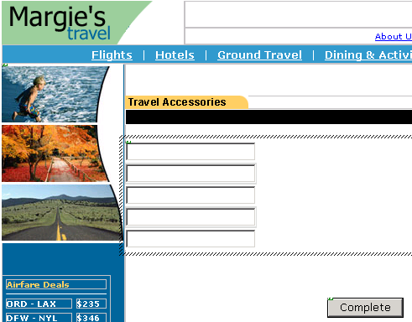
106. From the toolbox | Web Forms, drag a TextBox into the Item Template workspace in the first row of whitespace (as shown in the picture above)
NOTE: When you drag an item off the toolbox to the form, if you wait a few seconds, the Toolbox will autohide

107. Right mouseclick on the DataList control at the top dark grey part of the control and choose End Template Editing
108. Switch to HTML view by click on the tab at the bottom left of the code window just above the command window
109. In the HTML view code window, Scroll down to the DataList ItemTemplate (near the bottom of the file)
110. Select this entire line of text in the code
<asp:TextBox id=TextBox1 runat="server"></asp:TextBox>
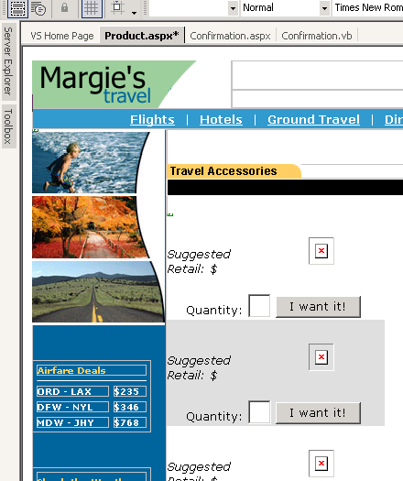
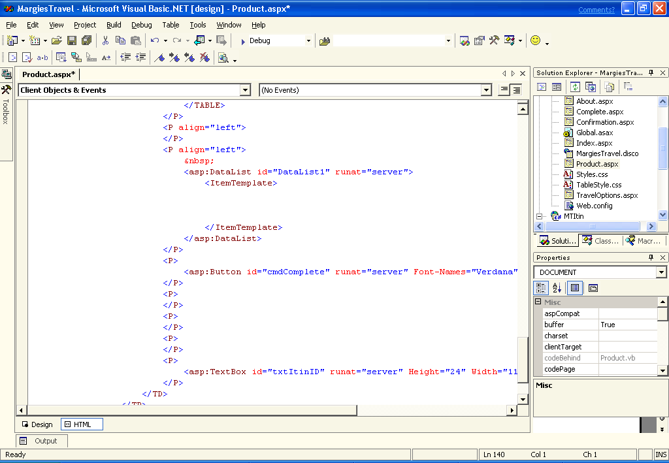
111. Delete the line of code you selected and keep your cursor on that line you deleted

112. You can hit Enter a few times to give yourself some space
113. From the toolbox Snippets Tab, double-click the Product List code snippet
114. Switch back to Design view and view the changes (See figure to the left)
115. From the menu select Project | Add Web Reference
116. Select the link Web Reference on Local Web Server
117. Select the link http://localhost/ProductService/ProductService.vsdisco
Note: If you don’t see a list of Available references after clicking on the Web References on Local Web Server link, you can get the reference by typing the web service URL (http://localhost/ProductService/Product.asmx) directly into the Address text box on this dialog and hitting the Enter key.
118. Click on the Add Reference
119. Double click on the right on the Product.aspx page in the designer (empty whitespace to the right of the I want it! Button) to open the code behind and expose the Product_Load event
120. Place your cursor below this line and hit Enter a couple times to give yourself some room
'TODO: Add Product XML Web service Call Here
121. From the toolbox Snippets tab, double click the
Product List - Product_Load code snippet and the code will be copied to where your cursor was in the code
Protected Sub Product_Load(ByVal Sender As System.Object, ByVal e As System.EventArgs)
If Not IsPostback Then ' Evals true first time browser hits the page
txtItinID.Text = Request.QueryString(“ItineraryID”)
TODO: Add Product XML Web service Call Here
Dim ProductService As New localhost1.Product()
Dim Products As DataSet

'get the related products
Products = ProductService.Browse

'bind the dataset to the list
DataList1.DataSource = New DataView(Products.Tables(0))
DataList1.DataBind()

End If
End Sub

(This code will call the XML Web service and bind the recordset to the DataList.)
121. From the menu select Build | Build Solution
122. You should see the following output in the Output window at the bottom of your screen:
Build: 3 succeeded, 0 failed, 0 skipped
123. Press F5 to run the Margie’s Travel web site
124. This time when you get to the Confirmation page, select the View Products button (you will have to scroll to see it)

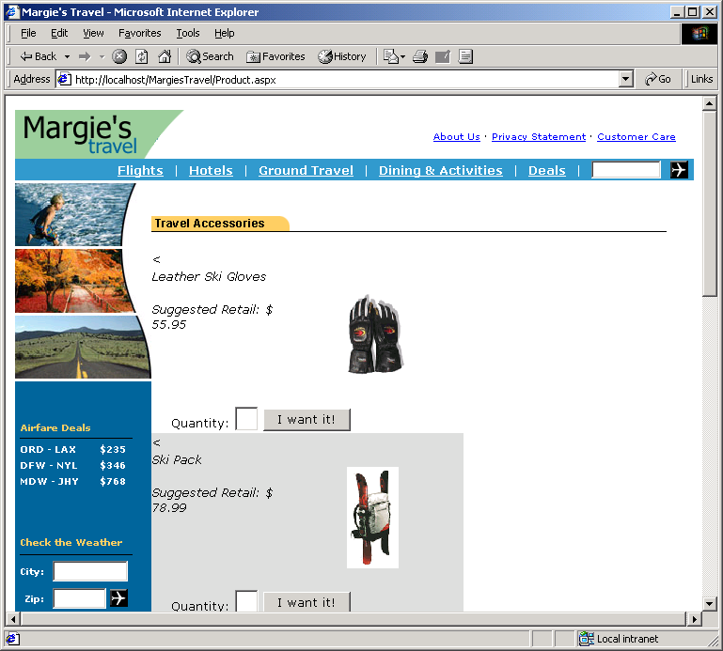
125. You should see the following Products Page in Internet Explorer:
126. Close Internet Explorer browser window
127. Close Visual Studio .NET by going to the menu and select File | Exit
128. If you get a message that asks you if you want to stop debugging, select Yes

7.6 Sumary
In this exercise you have designed, created, and tested a XML Web service to return a list of products using key enterprise features in Visual Studio .NET. You utilized the ORM Database Modeling and UML Class Modeling tools provided by Visual Studio .NET to design the application. When you built the Products XML Web service, you started with an ASP.NET Web Service Enterprise Template project and added your specific methods and connected it to a SQL Server 2000 database and used the DataAdapter Configuration Wizard to get the data. After the XML Web service was build, you took advantage of the Application Center Test tool integration within the IDE to perform load and functionality tests against your new web service.

8.1 Inheritance and Anchoring with Windows Forms

8. Advanced Visual Basic featureS
Windows Forms is a new forms package that enables developers building Windows-based applications to take full advantage of the rich user interface features available in the Microsoft Windows operating system. Windows Forms is part of the new Microsoft.NET Framework and leverages many new technologies, including a common application framework, managed execution environment, integrated security, and object-oriented design principles. In addition, Windows Forms offers full support for quickly and easily connecting to XML Web services and building rich, data-aware applications based on the ADO.NET data model. With the new shared development environment in Visual Studio, developers will be able to create Windows Forms applications using any of the languages supporting the .NET platform, including Microsoft Visual Basic and C#.

- Start Visual Studio .NET from the Start | Programs | Microsoft Visual Studio .NET 7.0 | Microsoft Visual Studio .NET 7.0
- From the menu select File | Open Solution… and browse to [Program Files]\MargiesTravel\AgentDesktop
- Select the AgentDesktop.sln file and click the Open button
- From the menu select Project | Add Web Reference
- Select the link Web References on Local Web Server
- Select the link http://localhost/ProductService/ProductService.vsdisco
Note: If you don’t see a list of Available references after clicking on the Web References on Local Web Server link, you can get the reference by typing the web service URL (http://localhost/ProductService/Product.asmx) directly into the Address text box on this dialog and hitting the Enter key.
- Click on the button Add Reference
- From the menu select Project | Add Inherited Form
- Enter the filename frmProduct
- Click Open
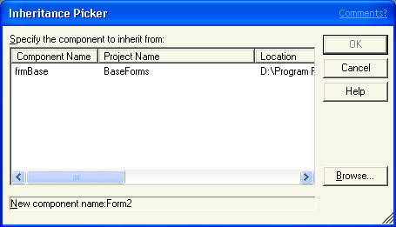
- Select frmBase from the Inheritance Picker Dialog and click OK
Note: If you see a dialog box stating that there are no inheritable classes available in the referenced projects, Right-click on the BaseForms project in the Solution Explorer and choose Build. Then attempt step 8 again.
- Double click frmProduct.vb in the solution explorer to open the form in design view
- Click on the lblDetail label under the Margie’s Travel image on the Windows Form
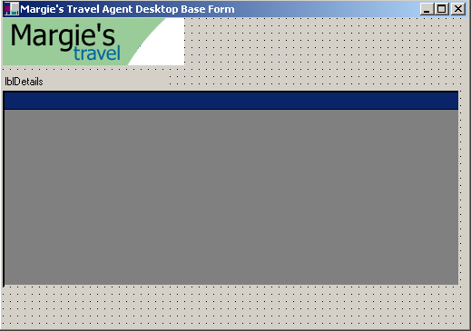
- In the properties window at the lower right of your screen select the attribute Text and to the right of it change the text from lblDetails to Select Product and press Enter
Notice how the lblDetails changes to Select Product
- Drag a Button from the Toolbox | Win Forms onto the form - next to lower right hand corner of the Windows Form
- Now change the text for the Button you just added by selecting the Text in properties page and changing it to Done
- Next, change the style of Button by selecting FlatStyle and changing that to Flat
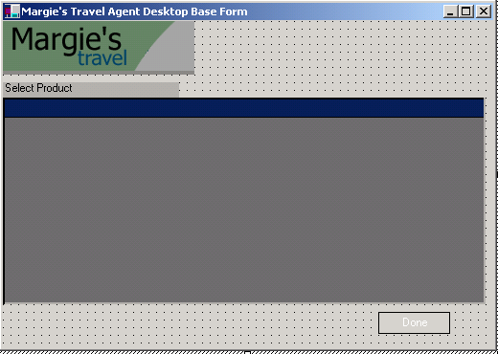
- 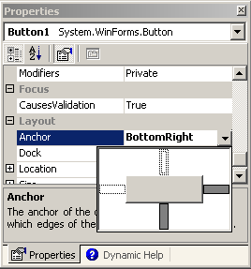Making sure you have the Done button you just created selected, In the Properties window,select the Anchor property and click the arrow to the right of the Anchor property.
- Click the top of the cross to clear the top anchor, and click the bottom of the cross to set the bottom anchor. Click on the Left to clear and the right to set the anchor See the completed figure to the left. (Shaded = Checked)
- Click the Anchor property name again to close the Anchor property editor
- Click the Form and drag resize point to make the form taller and see that the Done button stays anchored to the bottom right of the form
- Select the form by clicking on the top blue title bar of the form
- In the Toolbox | Win Forms, double-click the MainMenu control (as shown at the left)
- Click the menu control’s “Type Here” text, and type “File” and press Enter (below the Blue title bar that says Margie’s Travel Agent Desktop Base Form)
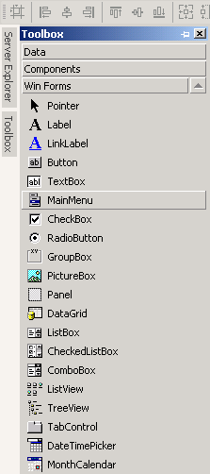
- Click the “Type Here” text below the File item and type “Exit” to add a sub item.
- On the product form in the design view, double-click on the empty grey space to the right of the Margie’s Travel image
- This will take you to the frmProduct_Load event handler in the code window.
- Double-click on the code snippet labeled AgentDesktop Product List

Dim ProductService As New localhost.Product()
Dim Products As DataSet
Products = ProductService.Browse
DataGrid1.DataSource = New DataView(Products.Tables(0))

- From the menu select File | Save All
- Press F5 to Run the application.
- View the output window at the bottom of your window and make sure the XML Web service built properly, it should read:
Build: 1 succeeded, 0 failed, 0 skipped
- Choose a client name from the drop down list
- Click the Create Itinerary button to see the new inherited form displayed.
- Click on the Add Products button to see the list of products being returned
- Close all Windows Form Windows with the X close button in the upper right hand corner
- Close the Visual Studio .NET by select File | Exit from the menu

8.2 Summary

In this exercise you have called the product XML Web service from a Windows Form. You used the inherited form feature of the .NET Framework as well as the Anchor property to automatically keep the object anchored when resizing.

9.1 Calling a COM+ Component – C++ Interoperability

9. Calling a classic com component – C++ interop

Managed extensions for C++ are a set of language extensions that help developers using Microsoft Visual C++ write applications for Microsoft .NET.
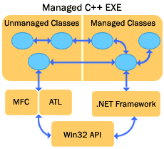
The managed extensions are useful if you:

Want to enhance developer productivity by using C++ to write .NET applications
Want to migrate a large body of code, in stages, from unmanaged C++ to the .NET platform
Have unmanaged C++ components that you want to use from .NET Framework applications
Have .NET Framework components that you want to use from unmanaged C++
Want to mix unmanaged C++ code and .NET code in the same application
Managed extensions for C++ offer unparalleled flexibility to developers targeting the .NET platform. Traditional unmanaged C++ and managed C++ code can be mixed freely within the same application. New applications written with managed extensions can take advantage of the best of both worlds.
In our case, we want to reuse an existing COM component. Existing components can be wrapped easily as .NET components by using Managed Extensions, preserving investment in existing code while integrating with .NET.

- Start Visual Studio .NET from the Start | Programs |Microsoft Visual Studio .NET 7.0 | Microsoft Visual Studio .NET 7.0
- Choose File | Open Solution… and browse to
CreditCard is the ATL component that implements the Luhn method

CreditCheck is the Managed C++ wrapper component.
[Program Files]\MargiesTravel\CreditCard\
- Select the CreditCard.sln solution and click Open
- From the menu choose Build | Rebuild Solution (this will take a few moments)
Rebuild All: 2 succeeded, 0 failed, 1 skipped

- From the menu select File | Open Solution…
Navigate to: Desktop - My Documents – Visual Studio Projects Select BusinessService.sln
- In Solution Explorer, select BusinessService project which is the bolded name second from the very top in the Solution Explorer window
- Right mouseclick, Choose Add Reference
- Browse to –
[Program Files]\MargiesTravel\CreditCheck\ debug\CreditCheck.dll
- Click Open to select the .dll
- Click OK to add the reference
- Open the CreditService.asmx file by selecting the tab above your code window
- Right mouse-click on the design surface to view code
Now you are going to delete the existing 5 lines of code in the CreditCardCheck Function and replace them with new code to call the C++ component
- Select the below 5 lines of code between the Public Function and End Function of the CreditCardCheck Function and Delete them
If CardNumber = "1234" Then
Return "Approved"
Else
Return "Denied"
End If

- Add a couple spaces between the Public Function and End Function
- Place the cursor in that empty space you created
- From the Toolbox Snippets tab double click on the code snippet Credit Check Component Call

Dim CreditService As New CreditCheck.CardCheck()
Return CreditService.CheckCardNumber(CardNumber)

- From the menu select Build | Build
- You should see the following output in the output window at the bottom of your screen
Build: 1 succeeded, 0 failed, 0 skipped
- Open Internet Explorer and type the following into the URL http://localhost/MargiesTravel/Index.aspx
- From the “From what are you escaping” dropdown menu Select Work
- From the “What are you escaping to do?” dropdown menu Select Skiing
- Click on the button at the bottom labeled “Escape Now!”
- Click on the “View/Edit Full Itinerary” button at the top right
- Click the Book This Trip! Button
- Enter a valid Credit Card number (get your wallet or purse) or enter a valid card and change one digit to make it invalid
- NOTE: This credit card number is valid: 4111111111111111 (no spaces are allowed)
- Click the button named button
- Congratulations! You have just completed the Visual Studio .NET Beta 2 Guided tour.

9.2 Summary

You have just taken an existing ATL COM component and made it accessible to the .NET languages by encapsulating it with small wrapper project around it using managed extensions in C++. We made no changes to this COM object and can now use Visual Basic.

1 Getting Started

Appendix A: Installing Visual Studio .NET Beta 2
This document contains last-minute notes from the Visual Studio .NET product teams that may help beta testers work around known issues in the Beta 2 release. For Visual Studio .NET known issues that emerged after this document's release, visit http://beta.visualStudio .NET. For additional .NET Framework SDK known issues, visit http://go.microsoft.com/fwlink/?LinkId=501.

Visual Studio .NET Beta 2 is designed for evaluation and education purposes on test equipment only. Creating and deploying production applications is neither supported nor recommended due to the pre-release status of the product. Installing to machines that you depend on for day-to-day operations either for yourself or for your business is strongly discouraged. You should save your work frequently.

Visual Studio .NET requires you to be an administrator on the local machine to effectively use all the provided tools. This requirement, combined with the fact that heavy security testing was not performed on Visual Studio .NET Beta 2, means that there are potential security issues which could be exploited.

Due to limitations of the Beta 2 release, executing managed applications created with Visual Studio .NET may result in unexpected security exceptions. For information regarding .NET Framework security specific to Beta 2, see the Security section of this readme under “Known Issues”. For information on code access security administration, see the “Runtime Code Access Security Administration Specification” in the .NET Framework SDK documentation.
Note The information contained in this document relates to pre-release software product, which may be substantially changed before its commercial release. This document is provided for informational purposes only. MICROSOFT MAKES NO WARRANTIES, EXPRESSED OR IMPLIED, WITH RESPECT TO THIS DOCUMENT OR THE INFORMATION CONTAINED IN IT.

1.1 Related Readmes

In addition to this Visual Studio .NET product readme, Visual Studio .NET also includes other readme documents that contain information pertinent to specific product areas. The following list contains the names of related readme documents and their locations on supplied media.
Content Name | File Name | Location
.NET Framework SDK | NA | http://go.microsoft.com/fwlink/?LinkId=501
VSIP & VSA SDK | Readme.htm | VSIP SDK CD in the root directory
VSS 6.0c | Readmess.htm | Visual SourceSafe 6.0c CD in the root directory
Duwamish 7.0 Visual Basic sample | readme.htm | Default location: [Drive letter where Visual Studio .NET is installed]:\Program Files\Microsoft Visual Studio .NET\Enterprise Samples\Duwamish 7.0 VB
Duwamish 7.0 C# sample | readme.htm | Default location: [Drive letter where Visual Studio .NET is installed]:\Program Files\Microsoft Visual Studio .NET\Enterprise Samples\Duwamish 7.0 CS
Fitch and Mather 7.0 sample | ReadMe.html | Default location: [Drive letter where Visual Studio .NET is installed]:\Program Files\Microsoft Visual Studio .NET\Enterprise Samples\FMStocks7
Academic Tools | Readme.txt | Academic Tools CD in the root directory
Application Center Test (ACT) | ReadMe.htm | [Drive letter where Visual Studio .NET is installed]:\Program Files\Microsoft ACT\

1.2 System Requirements
Visual Studio .NET Beta 2 is designed for evaluation and education purposes on test equipment only. Installing on computers upon which you depend for day-to-day operations, either for yourself or for your business, is strongly discouraged. This beta software should only be installed on test machines that can be reformatted if needed.

Creating and deploying production applications is neither supported nor recommended, due to the stage of the tool's development. Users should save their work frequently. Performance has not been tuned for minimum requirements. Using the recommended system configuration will maximize performance.

To use Microsoft Visual Studio .NET Beta 2, you need:
Processor: PC with a Pentium II-class processor, 450 MHz
(recommended: Pentium III-class, 600MHz)
RAM: Windows 2000 Professional — 96 MB; Windows 2000 Server — 192 MB
(recommended: 128MB for Professional, 256 MB for Server)
Available Hard Disk Space: 500 MB on system drive, 2.5 GB installation drive
Note When you start the Visual Studio .NET installer, the default installation location is your system drive, which is the drive that boots your system. However, you can install the application on any drive. Regardless of the application's location, the installation process installs some files on your system drive. Consequently, ensure that the above amount of space is available on your system drive regardless of the application's location, and ensure that additional space (as listed above) is available on the drive on which you install the application.
Operating System: Windows® 2000, Windows XP Beta 2, and Windows NT 4.0
CD-ROM Drive: Required
Video: 800 x 600, 256 colors (recommended: High Color 16-bit)
Mouse: Microsoft Mouse or compatible pointing device

2 Installation

2.1 Uninstalling previous versions of Visual Studio .NET
For customers with DVD installation media, there is one disc. For customers with CD installation media, there are four CDs: Windows Component Update, Visual Studio .NET CD1, Visual Studio .NET CD2, and Visual Studio .NET CD3.
Warning If you have previously installed Visual Studio .NET 7.0 Beta 1 or PDC Technology Preview on your computer, you must complete the following steps to uninstall the previous release. If possible, it is recommended that you reformat your machine before installing Visual Studio .NET Beta 2. Installing Visual Studio .NET Beta 2 on a machine where previous versions of Visual Studio .NET have been installed and uninstalled has not been thoroughly tested.

To uninstall Visual Studio .NET 7.0 Beta 1
- From the Start menu, choose Settings and then Control Panel.
- Choose Add/Remove Programs and then choose Change or Remove Programs.
- Select Visual Studio .NET 7.0 Enterprise and choose Change/Remove.
- Click link 2, Visual Studio .NET.
- Click Uninstall Visual Studio .NET 7.0 Enterprise to begin uninstall.
- After uninstall completes for Visual Studio .NET 7.0 Beta 1, return to the Add/Remove Programs window.
- Select Microsoft .NET Framework SDK and choose Change/Remove.
- Answer Yes to proceed with removal.

To uninstall Visual Studio 7.0 PDC Technology Preview
- From the Start menu, choose Run.
- In the Run dialog box, type the following: msiexec.exe /x {33334F07-0C6B-11D3-A51D-00A0C9231BA1} NOVSUI=1
- Answer Yes, when prompted, to proceed with the removal of Visual Studio .NET PDC Technology Preview.
- In the Run dialog box, type the following: msiexec.exe /x {62EDCF3C-69F4-11D3-A521-00A0C9231BA1}
- Answer Yes, when prompted, to proceed with removal of the Pre-release Bootstrap for Visual Studio .NET PDC Technology Preview.
- From the Start menu, choose Settings and then Control Panel.
- Choose Add/Remove Programs and then choose Change or Remove Programs.
- Select Microsoft NGWS SDK and choose Change/Remove.
- Answer Yes to proceed with removal.
- Remove all files from n:\Documents and Settings\All Users\Application Data\Microsoft Help. This step ensures that PDC release documentation is removed and that only beta documentation appears.

2.2 Installing Microsoft® Visual Studio .NET Beta 2
- Close all open applications.
- Insert the CD labeled Visual Studio .NET CD1 or DVD.
Autorun starts Setup.exe. If Autorun is disabled, run Setup.exe from the root of the CD or DVD using Windows Explorer.
If you plan to install Visual Basic.NET or C#.NET do not uncheck the .NET Framework SDK feature on the setup options screen. It is checked by default. See Section 4.3.13 for more information.

2.3 Configuring a Web server for Visual Studio .NET
To work with Web applications in Visual Studio .NET, your development computer and Web server (which might be the same computer) must be properly configured.

Requirements
The following lists the operating system requirements for working with Web Forms and Web Services in Visual Studio .NET:
- The Web server (which can be your local computer) must be running Windows 2000 or Windows XP. You cannot use a computer running Windows 95, Windows 98, Windows ME, or Windows NT 4.0 as a Web server (that is, Personal Web Server and IIS 4.0 are not supported).
- It is recommended, but not required, that the Web server be installed on a computer formatted with the NTFS file system. However, FAT and FAT32 are supported.
- The Web server must be running Internet Information Server (IIS) version 5.0 or later. If the Web server is running Windows 2000, be sure that you have installed IIS. For details see Setup\WebServer.htm on Visual Studio .NET CD1 or DVD.
Configuring the Server Computer
If you are developing on one computer with Visual Studio .NET but want to deploy your Web applications to a separate Web server computer, you must configure the server computer properly. Doing so requires installation of some Visual Studio .NET components on the Web server computer.
Note If you are using your development computer as the Web server, you do not need to follow this procedure; installing Visual Studio .NET on your computer configures it properly.
To configure a separate Web server computer for Visual Studio .NET
- Run Visual Studio .NET setup on the Web server computer and perform Step 1 to install the Windows Component Update.
- This installs the .NET Framework on the server computer. When this step is complete, the setup process returns to Step 2 of the Visual Studio .NET installation.
- Start Step 2 of the setup process. In the left pane of the setup window are a number of options for the installation. You should:
- Clear the selection of all options except Server Components.
- Expand the Server Components node and select Web Development and Remote Debugger.
Then click Install Now to proceed with installation.
- Verify that FrontPage Server Extensions are configured. For details, see Setup\WebServer.htm on Visual Studio .NET CD1 or DVD.

2.4 Remote Debugger installation
If you intend to debug processes on a remote machine, you must install the Remote Debugger. For more information, see ServerSetup.htm at the root of Visual Studio .NET CD1 or DVD.

2.5 Uninstalling Microsoft® Visual Studio .NET Beta 2
To uninstall Visual Studio .NET Beta 2, use Add/Remove Programs from the Control Panel.

2.5.1 Uninstalling baseline components
Uninstalling Visual Studio .NET version 7 Beta 2 does not uninstall components installed by Windows Component Update. For components that offer individual uninstall, use the Add/Remove Programs in the Control Panel.

2.5.1.1 Uninstalling system service packs
If you have not installed Windows NT 4.0 Service Pack 6a or Windows 2000 SP2 prior to installing Visual Studio .NET and you want to be able to uninstall the service package, you should manually install the service pack and enable the option to backup files for uninstall before you install Visual Studio .NET. Although Visual Studio .NET installs the appropriate service pack as part of its update of system components, the Visual Studio .NET installation does not create the uninstall directory.

2.6 Known Installation Issues

2.6.1 Error "Setup cannot find the original installation source location..."
When Setup is run in maintenance mode from Add/Remove Programs in the Control Panel, you may receive the following error message when adding features:
- "Setup cannot find the original installation source location at <path to original install point>. Please check your drives and ensure setup can be found at that location."
- "Error 1706. No valid source could be found for product Visual Studio .NET 7.0. The Windows installer cannot continue."
This message appears because the CD or network location from which Visual Studio .NET was installed is no longer present. Installation fails following the appearance of these messages.

To overcome this problem:
- In the Setup Failed page, click Done.
- Insert Visual Studio .NET CD1 or Visual Studio .NET Professional DVD into your computer.
- Click link 2, Visual Studio .NET.
- Click Add or Remove Feature.
- On the Setup Options Page, reselect the features you want to Add or Remove and click Update Now.

2.6.2 Error "Selected drive is no longer valid" when installing Visual Studio .NET.
Visual Studio .NET cannot be installed to UNC paths (for example, \\servername\folder). The installation path must include a drive letter.

To work around this issue:
- Use Windows Explorer to map the UNC path to a drive letter on the local computer.
- On the Options Page of the Microsoft Visual Studio .NET 7.0 Setup wizard, type the new path into Path under Feature Properties.

2.6.3 Visual Studio Beta 2 may not work if you upgrade your operating system.
If you upgrade your operating system after installing Visual Studio .NET Beta 2, Visual Studio .NET Beta 2 may fail to operate correctly.
To avoid this situation, upgrade your operating system before installing Visual Studio .NET Beta 2.

2.6.4 Setup errors when registry size is insufficient
If the registry is low on space, errors such as 'Error: could not locate INF file' could occur during setup.
To avoid such errors, increase the maximum registry size limit.
Note You must be logged on as administrator to the local computer to change registry size.
To change the maximum size of the computer's registry
On Windows 2000
- Click Start, point to Settings, click Control Panel, and then double-click the System icon.
- On the Advanced tab, click Performance Options, and click Change in the Virtual memory section.
- Type a new value in the Maximum registry size (MB) field.
On Windows NT 4.0
- Click Start, point to Settings, click Control Panel, and then double-click the System icon.
- On the Performance tab, click Virtual memory, and then click Change.
- Type a new value in the Maximum registry size (MB) field.

2.6.5 After uninstalling Visual Studio .NET Beta 2, Visual InterDev 6.0 cannot create a New Web Project.
After uninstalling Visual Studio .NET you will be unable to create a New Web Project in Visual InterDev 6.0.
The problem can be fixed by running repair/reinstall for Visual InterDev 6.0.

2.6.6 Error messages when running Setup
When running Setup, you may see the error message "A problem has been encountered while loading the setup components. Canceling setup." This error occurs when critical Setup files are missing. If you are installing from a network image, recopy the CDs or DVD to make sure all files are present.
You may also see the error message "Failed to populate selection tree." This error occurs when a previous release of Visual Studio .NET, such as Beta 1, is installed on the machine.
For instructions on uninstalling the Beta 1 or PDC Technology Preview release, see Section 2.1 of this readme.

2.6.7 Install the Current Driver for your Video Display Card.
Make sure that the current driver for your video display card is installed on your machine. Outdated video display card drivers have been identified as the cause of problems like the following:
- Certain Gateway install CDs provide outdated drivers for ATI RAGE 128 PRO video display cards. When you launch Visual Studio .NET Beta 2 on such machines, the outdated video driver creates a URT Null Reference exception that crashes the program.
- When you attempt to rename items in a tree or list box control on a Windows NT 4.0 machine with an ATI 3D Rage Pro AGP video display card, an outdated video driver can cause all text in the control to be rendered invisible.
To prevent such problems:
Download and install the current driver for your video display card. To obtain a current driver, contact the manufacturer of the card. For ATI video display card drivers and information about them, see the following pages on the ATI website:

Rage Pro Drivers http://support.ati.com/products/pc/ragepro/ragepro.html

ATI Special Purpose Display Drivers http://www.ati.com/na/pages/spdrivers/index.html?parent=0&folder=68&doc=53

Getting Around Windows NT 4.0 http://support.ati.com/faq/winnt/winnt_config.html

Installation Procedures for the ATI NT 4.0 Display Driver http://driver.atitech.ca/drivers/n42040en.htm

Minimum requirements for AGP support in Windows NT 4.0 http://support.atitech.ca/infobase/2902.html

2.6.8 ATI Rage Video Driver and True Color Settings
Machines with ATI Rage Video drivers should not use the True Color display setting when installing Visual Studio .NET Beta 2. This hardware and display setting combination causes a crash when installing or running Visual Studio .NET.
To change the display setting:
- On the Start menu, select Settings and then choose Control Panel.
- Select Display and then choose the Settings tab.
- In the Colors drop-down list, choose an option, such as High Color.

2.6.9 Setup user interface is inaccessible when using Matrox G400 Max dual Monitor.
Users of the Matrox G400 Max dual Monitor video card may find that certain areas of the user interface are inaccessible during setup.
To correct this problem, download the latest drivers from the Matrox Web site at http://www.matrox.com.

2.6.10 AppServer setup allows installation on unsupported platforms.
AppServer is only supported on Windows 2000 and Windows XP Professional. Installation is allowed on other platforms, but it is not supported.

2.6.11 Visual C++ and Visual C# wizards will not work if you have DBCS characters in the path.
If you have DBCS characters in the product install path, the wizards UI will be broken.
Do not use DBCS characters in the install path of Visual Studio .NET.

2.6.12 MDAC 2.7 does not work with SQL Server 6.5 and SQL Server 7.0.
Visual Studio .NET installs MDAC 2.7 by default. For MDAC 2.7 to work with SQL Server 6.5 and SQL Server 7.0, you must run Instcat.sql to upgrade the catalog stored procedures.

To use MDAC 2.7 with SQL Server 6.5 and SQL Server 7.0, use the isql utility to run the Instcat.sql script from SQL Server 2000. The Instcat.sql file is in the SQL Server 2000 Evaluation Edition provided with Visual Studio .NET Enterprise Edition.

2.6.13 OLE DB Provider does not work correctly.
The Microsoft OLE DB Provider for SQL Server is implemented as a dynamic link library (DLL) on the client machine and a set of stored procedures on the server. Unless both parts are installed, the OLE DB provider does not function correctly. The DLL on the client machine is Sqloledb.dll. The script Instcat.sql installs the stored procedures on the server.

If you install a newer version of Sqloledb.dll but do not run Instcat.sql on each SQL Server machine running OLE DB, some OLE DB functions will return incorrect results.

If you install a newer version of Sqloledb.dll, make sure you run Instcat.sql on each SQL Server machine running OLE DB.

2.6.14 Cannot install Visual Studio Analyzer Server on Win9x.
Setup will not run on Win9x. Running Setup.exe on Win9x returns an error message that asks for "Win NT4 or later".
To install Server Components on your Win9x system, run ServerSetup.htm and follow the instructions. ServerSetup.htm is located in the root directory of the CD labeled Visual Studio .NET CD1 or DVD in your Visual Studio .NET Enterprise box.

3 Providing Feedback
For Visual Studio .NET Beta 2, you have an opportunity to provide feedback about various aspects of Visual Studio .NET, such as the product and documentation.
The beta releases of Visual Studio .NET are instrumented to capture three types of information from beta testers.
- product usage information in a log file
- state information in a crash dump whenever the development environment crashes and
- feedback on user interface elements and dialog messages.
The development team uses these logs and reports to identify where to target stability and performance work before the product is released in its final form.

The product usage log is only allowed to grow to 125Kb in size. When the log file reaches the 125Kb threshold, the environment will automatically prompt you to upload the log to a Microsoft Web site. If you decide you do not want to provide your logs to the development team, choose the Cancel button when prompted to upload the file. The log file is cleared whether or not you choose to upload it. In summary, the development environment is always capturing data, and you have a choice about uploading it to Microsoft. The file will never grow larger than 125Kb.

A second automatic mechanism for product feedback is the crash dump that is automatically generated whenever the development environment crashes. For developers familiar with the Windows Dr. Watson dumps, this is a similar mechanism. If the Visual Studio .NET environment crashes, you see a dialog box asking you to report this crash to Microsoft. You are directed to a Web page containing the Microsoft policy on data privacy. If you choose OK to proceed, you will upload binary information about the crash to the Microsoft Watson server.

Finally, the Feedback site can be accessed using the Customer Feedback button (the "smiley face" on the Standard toolbar) within the Visual Studio .NET environment, by navigating directly to the Web site at http://beta.visualStudio .NET, or by choosing the "LAME!" button on an error message dialog box or in a Help topic. Telephone support is not available for this release.

A link to the Visual Studio .NET Beta 2 Feedback Web page is at the bottom of each topic within the Visual Studio .NET documentation set. On this Web page you can submit comments and suggestions about the topic to Microsoft.

